Name: ___________________________ Date: ____________________________

UNIT 10 LESSON 1

**AIM**: SWBAT use angle relationships to determine angle measurements

**THINK ABOUT IT!**

Use the diagrams below to determine the measure of the missing angle

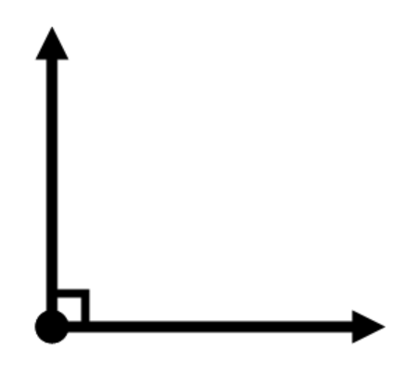

A = ?

B = 30°

C = 80°

D = ?



Key Point:

|  |
| --- |
|  |

**Interaction with New Material**

Ex.1) Use the diagram below to answer the following questions

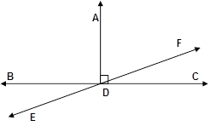

cid:image008.png@01D18B31.C986AD40ADF measures 2x degrees and cid:image008.png@01D18B31.C986AD40FDC measures x + 12 degrees. What is the measure of each angle?

**PARTNER PRACTICE**

|  |
| --- |
| *Bachelor Level* |

1. Does an angle relationship exist between the two angles shown? If there is one, explain what it is and how you know. If there isn’t one, explain why not.

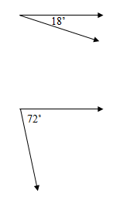

____________________________________________________________________________________________________________________________________________________________________________________________________________________________________________________________________________________________________________________________________________________________

1. 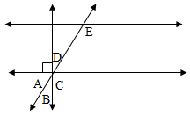Which angle is the complement to Angle B?

**A** A **B** C **C** D **D** E

Explain your reasoning:

____________________________________________________________________________________________________________________________________________________________________________________________________________________________________________________________________________________________________________________________________________________________

|  |
| --- |
| *Master Level* |

1. If m∠BDE is 32º, what is mBDF?

Explain your reasoning:   
______________________________________________________________________________________________________________________________________________________________________________

_______________________________________________________________________________________

1. Mr. Mieze solved the problem above and said that m  BDF = 58º. What was his misunderstanding?

______________________________________________________________________________________________________________________________________________________________________________

______________________________________________________________________________________________________________________________________________________________________________

1. In the diagram below, angle ABE is 90º. Angle EBD measures 3x and angle DBC measures 2x – 10. What are the measures of angles EBD and DBC?

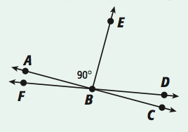

**INDEPENDENT PRACTICE**

|  |
| --- |
| *Bachelor Level* |

Use the diagram below to answer questions 1-4

1. 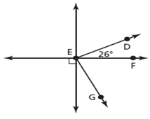What is the relationship between ∠ DEF and ∠ EFG, if  DEG measures 90º?

___________________________________

1. What is m∠ GEF?

**H**

1. Explain your reasoning for #2:

_____________________________________________________________________________________________________________________________________________________________________________________________________________________________________________________________________

1. Show how you could solve problem 2 using an equation.
2. Nigel argues that the supplement of a 64º angle must have a measure of 24º. Is Nigel correct or incorrect? How do you know?

____________________________________________________________________________________________________________________________________________________________________________________________________________________________________________________________________________________________________________________________________________________________

|  |
| --- |
| *Master Level* |

1. Use the diagram below to answer the following questions. Line CP is a straight line.

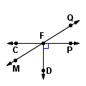

* 1. Angle QFC measures 4x + 12 degrees and angle CFM measures x + 13 degrees. What are the measures of angles?
  2. What is the measure of angle MFD?

1. Can two obtuse angles be supplementary? Explain your reasoning.

___________________________________________________________________________________________________________________________________________________________________________________________________________________________________________________________________________________________________________________________________________________________________________________________________________________________________________________

1. 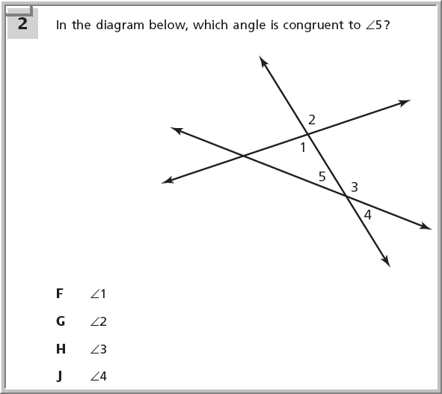Use the diagram below to answer the following questions. Angle 1 measures 5x, angle 5 measures 2x + 5, and angle 3 measures 8x – 10
   1. What is the measure of angle 3?
   2. What is the measure of angle 5?
   3. What is the measure of angle 4?
2. Are supplementary angles always, sometimes, or never equal? Explain your reasoning with examples.

___________________________________________________________________________________________________________________________________________________________________________________________________________________________________________________________________________________________________________________________________________________________________________________________________________________________________________________

|  |
| --- |
| *PhD Level* |

1. The measure of∠MAN is 6x + 10. The measure of MAL is 2x – 8. What are the measures of all four angles shown in the diagram?

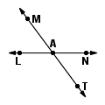

1. What do you notice about the measure of the angles formed from the intersecting lines in the previous problem?

___________________________________________________________________________________________________________________________________________________________________________________________________________________________________________________________________________________________________________________________________________________________________________________________________________________________________________________

**Name: ______________________________ Date: _______________________**

**EXIT TICKET**

|  |  |  |  |
| --- | --- | --- | --- |
| Self-assessment | I mastered the learning objective today. | I am almost there. | Need more practice and feedback. |
| Teacher feedback | You mastered the learning objective today. | You are almost there. | You need more practice and feedback. |

1. Using the diagram below, determine which statements are true and which statements are false.



|  |  |  |
| --- | --- | --- |
| Statement | True | False |
| Angle ADB is supplementary to angle ADC |  |  |
| Angle ADB is complementary to angle ADC |  |  |
| Angle ADF is complementary to angle FDC |  |  |
| Angle ADF is supplementary to angle FDC |  |  |
| Angle EDA is supplementary to angle ADF |  |  |

1. If angle EFR measures 38 + x and is supplementary to SFR which measures 135 degrees, what is the value of x?

