Name: ___________________________ Date: ____________________________

UNIT 10 LESSON 9

**AIM**: SWBAT use tools to construct triangles with two angles and one side

**THINK ABOUT IT!**

Q’marah and Vincent are trying to determine if the two triangles shown below are identical. Q’marah says that she can’t determine if they are identical because she was not given a ruler or protractor. Vincent says he can use unique triangle criteria to prove they are identical. Who do you agree with and why?

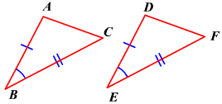

____________________________________________________________________________________________________________________________________________________________________________________________________________________________________________________________________________________________________________________________________________________________________________________________________________________________________________________________________________________________________________________________________________________________________________________________________________

Key Point:

|  |
| --- |
|  |

**Interaction with New Material**

Ex. 1) The two triangles are formed from intersecting lines BC and AD. Are the triangles identical? Explain.

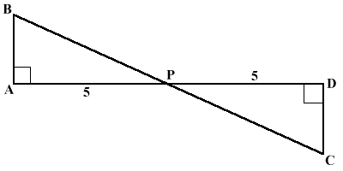

__________________________________________________________________________________________________________________________________________________________________________________________________________________________________________________________________________________________________________________________________________________________________________________________________________________________________________________________________________________________________________

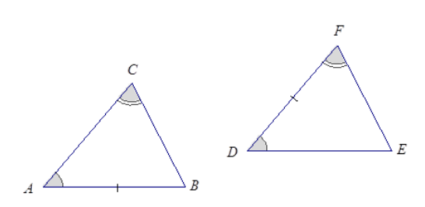Ex. 2) The triangles below have two congruent angles and one congruent side. Are the triangles congruent? Explain.

__________________________________________________________________________________________________________________________________________________________________________________________________________________________________________________________________________________________________________________________________________________________________________________________________________________________________________________________________________________________________________

**PARTNER PRACTICE**

|  |
| --- |
| *Bachelor Level* |

1. Are the two triangles below identical? Explain your reasoning.

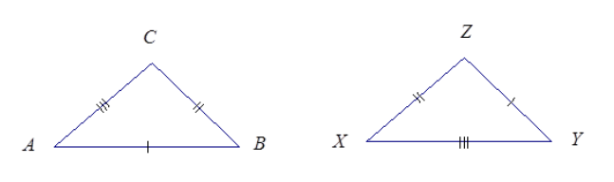

____________________________________________________________________________________________________________________________________________________________________________________________________________________________________________________________________________________________________________________________________________________________

1. Are the two triangles below identical? Explain your reasoning.

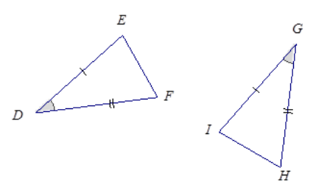

____________________________________________________________________________________________________________________________________________________________________________________________________________________________________________________________________________________________________________________________________________________________

|  |
| --- |
| *Master Level* |

1. Diego says that the two triangles formed below identical because they look like they are the same size. Do you agree or disagree with his claim? Explain your reasoning.

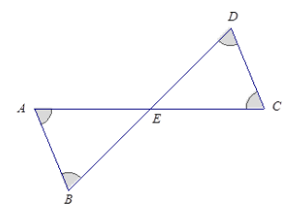

**____________________________________________________________________________________________________________________________________________________________________________________________________________________________________________________________________________________________________________________________________________________________**

**INDEPENDENT PRACTICE**

|  |
| --- |
| *Bachelor Level* |

1. Are the two triangles below identical? Explain your reasoning.

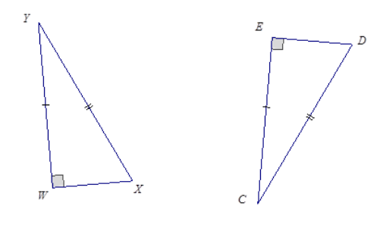

**____________________________________________________________________________________________________________________________________________________________________________________________________________________________________________________________________________________________________________________________________________________________**

|  |
| --- |
| *Master Level* |

1. Three pieces of information are given below describing triangles ABC and XYZ. Draw freehand the two triangles (do not worry about scale) and mark the given information. Use your drawing and annotations to determine if the triangles are identical and explain.



____________________________________________________________________________________________________________________________________________________________________________________________________________________________________________________________________________________________________________________________________________________________

1. Are the triangles below identical? Explain your reasoning.

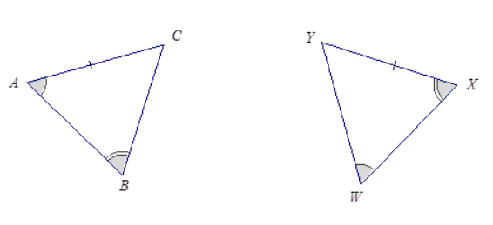

___________________________________________________________________________________________________________________________________________________________________________________________________________________________________________________________________________________________________________________________________________________________________________________________________________________________________________________

1. The bridge below, which crosses a river, is built out of two triangular supports. The point M lies on the line BC. The beams represented by line AM and DM are equal in length, and the beams represented by lines AB and DC are equal in length. If the supports were constructed so that angle A and D are equal in measurement, is point M the midpoint of BC? Explain.

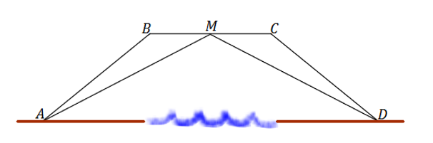

___________________________________________________________________________________________________________________________________________________________________________________________________________________________________________________________________________________________________________________________________________________________________________________________________________________________________________________

1. Are there any triangles that are identical in the diagram below? Explain.

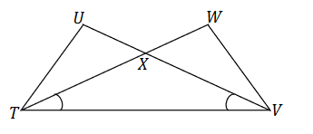

___________________________________________________________________________________________________________________________________________________________________________________________________________________________________________________________________________________________________________________________________________________________________________________________________________________________________________________

|  |
| --- |
| *PhD Level* |

1. 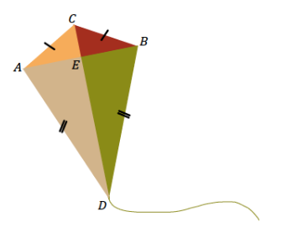Quadrilateral ACBD is a model of a kite. The diagonals AB and CD represent the sticks that help keep the kite rigid.

Step A: John says that angle ACD is equal to angle BCD. Can you use identical triangles to show that John is correct?

____________________________________________________

____________________________________________________

_____________________________________________________________________________________________________________________________________________________________________________________________________________________________________________________________________

Step B: Jill says that the two sticks are perpendicular to each other. Use the fact that angle ACD is equal to BCD and what you know about identical triangles to show angle AEC = 90 degrees.

____________________________________________________________________________________________________________________________________________________________________________________________________________________________________________________________________________________________________________________________________________________________

Step C: John says that Jill’s triangle correspondence that show the sticks are perpendicular to each other also shows the sticks cross at the midpoint of the horizontal stick. Is John correct? Explain.

____________________________________________________________________________________________________________________________________________________________________________________________________________________________________________________________________________________________________________________________________________________________

**Name: ______________________________ Date: _______________________**

**EXIT TICKET**

|  |  |  |  |
| --- | --- | --- | --- |
| Self-assessment | I mastered the learning objective today. | I am almost there. | Need more practice and feedback. |
| Teacher feedback | You mastered the learning objective today. | You are almost there. | You need more practice and feedback. |

1. In the following problem, two triangles are given. Ms. Chibbaro does not think the triangles are identical because they are facing different ways. Do you agree or disagree with her claim? Justify your answer.



___________________________________________________________________________________________________________________________________________________________________________________________________________________________________________________________________________________________________________________________________________________________________________________________________________________________________________________

1. A triangular fence with two equal angles, ∠𝑺 = ∠𝑻, is used to enclose some sheep. A fence is constructed inside the triangle that exactly cuts the other angle into two equal angles: ∠𝑺𝑹𝑾 = ∠𝑻𝑹𝑾. Show that the gates, represented by 𝑺𝑾 and 𝑾𝑻, are the same width.



___________________________________________________________________________________________________________________________________________________________________________________________________________________________________________________________________________________________________________________________________________________________________________________________________________________________________________________