Name: ___________________________ Date: ____________________________
UNIT 4 LESSON 20

AIM: SWBAT solve contextual problems involving circumference and area of circles.

THINK ABOUT IT!
The distance around Sally’s front wheel of her bike is 75.36 inches. Sally wants to attach four decorative spokes to her front wheel that go from the center of the wheel to the edge of the tire. Approximately how many inches of the decorative spokes does she need to buy to complete the project?

Key Point
Interaction with New Material
Ex. 1) The exact area of a circular track is 144π square meters. The school wants to put a fence around the outside of the track. What is the approximate length of fencing that the school will need to purchase in order to completely fence in the track?

PARTNER PRACTICE

Bachelor Level

- The distance from one side of a merry-go-round to the other is 13.6 ft. What is the approximate distance around the merry-go-round?

- Alex is working with a circle that has a circumference of 18π inches and makes the following claims. Decide whether you agree with each claim. Mark Yes or No.

Statement | Yes | No
The radius is equal to 18 inches
The diameter can be found by multiplying the radius by 2
The area is equal to 81π square inches

Master Level
- Ms. Regan is making a circular quilt and wants to include a lace pattern around the outside of the quilt (see below). About how many feet of lace does Ms. Regan need to purchase? Use 3.14 for pi.

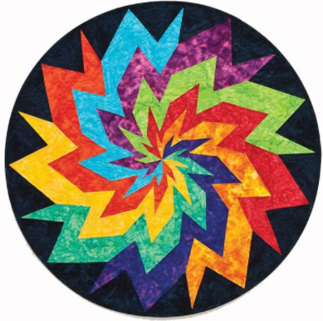

Area = 12.56 square feet
INDEPENDENT PRACTICE

Bachelor Level

- A paper snowman is made with two circles stacked on top of each other. Read each statement below and decide if it is “True” or “False.” Show your work.

 | True | False
The total area of the snowman is 100π square inches
The total area of the snowman is about 87.92 square inches
The distance around the head of the snowman is 6π inches
The distrance around the head of the snowman is about 37.68 inches

Master Level

- Ms. Menardy bought a new tablecloth for her dining room table that approximately covers the table’s 28.26 square feet. What is the distance, in feet, around the outside of the table?

- The distance around the lens of a magnifying glass is 26.376 cm. How many square centimeters of glass are needed to make the magnifying glass?

- The distance across the bottom of a candle is 12.28 in. Ms. Regan bought 6 candles and wants to put them on her dresser. How many square inches will the base of the candles take up on her dresser?

- The circumference of one Frisbee is 50.24 inches. How many more square inches of space does the Frisbee take up compared to a Frisbee that has a diameter of 12 inches?

- 37.68 sqin
- 12.56 sqin
- 62.8 sqin
- 87.96 sqin

6. If xπ square inches of cloth are needed to create a border around a table, which of the following represents the length from the center to one point on the outside of the table?
a) (2)(x)

b) $\frac{x}{2}$

c) x²

Explain your answer:

__________________________________________________________________________________________

__________________________________________________________________________________________

__________________________________________________________________________________________
PhD Level

- The largest particle collider in the world is in Europe and has successfully detected the “God Particle” known as a Higgs Boson which is believed to give mass to all solid matter. The collider is called CERN and is built underground in a circle and spans across two different countries! Physicists accelerate protons at near the speed of light and smash them into each other to “break” them open and study what all matter is made of. Protons typically make at least 575 full laps around the collider before colliding with another particle. If this distance is approximately 15,527.3 kilometers, what is the total area of the particle collider?
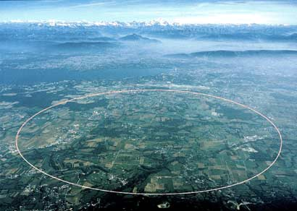

- What is the radius of a circle whose area and circumference have the same numeric value?

Name: ______________________________ Date: _______________________
EXIT TICKET
Self-assessment | I mastered the learning objective today. | I am almost there. | Need more practice and feedback.
Teacher feedback | You mastered the learning objective today. | You are almost there. | You need more practice and feedback.

1. The base of John’s coffee cup has a circumference of 12πcm. Exactly how much space does the base of the coffee cup take up?

