Name: ___________________________ Date: ____________________________
UNIT 5 LESSON 12

AIM: SWBAT determine if figures are scale drawings of each other and calculate their scale factor

THINK ABOUT IT!
Rectangle A was magnified to create Rectangle B.

Step A: Identify the corresponding side lengths
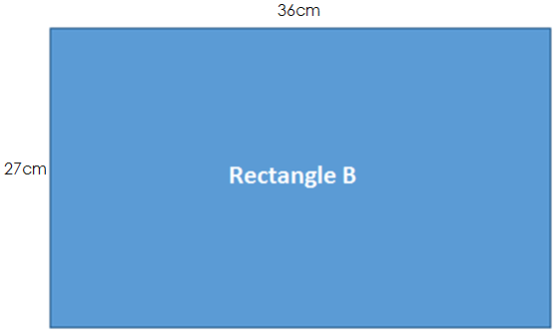

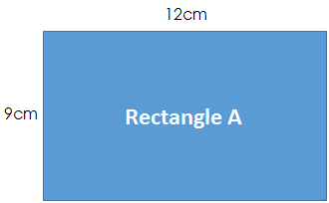

Step B: Explain what you notice about the corresponding side lengths.

______________________________________________________________________________________________________________________________________________________________________________________________________________________________________________________________________________________________________

Step C: What can you conclude about the rectangles? Explain.

______________________________________________________________________________________________________________________________________________________________________________________________________________________________________________________________________________________________________

Test the Conjecture 1) Is figure B a scale drawing of figure A? If so, what is the scale factor?
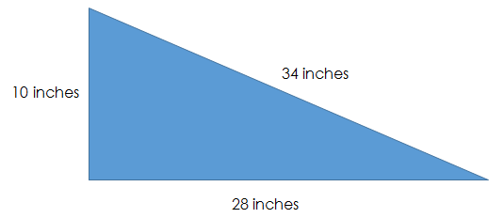
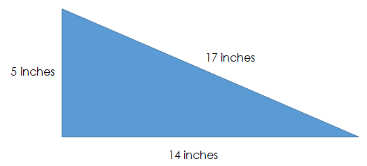

Figure B

Figure A

Test the Conjecture 2) Determine the scale factor applied to figure A that created figure B.
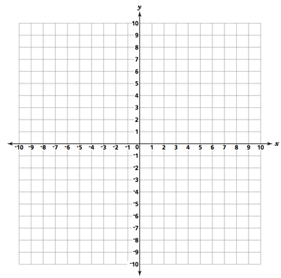
Figure B
Figure A
Conjecture

PARTNER PRACTICE

Bachelor Level

- Determine if the two figures could be scaled figures. Explain.

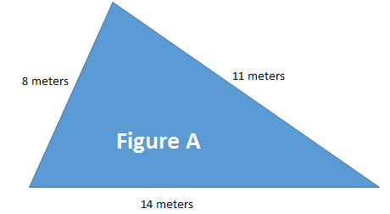
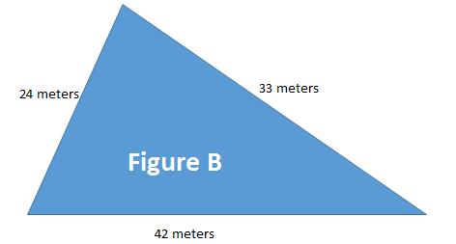

___________________________________________________________________________________________

___________________________________________________________________________________________

____________________________________________________________________________________

____________________________________________________________________________________

- What scale factor could be applied to Figure A to produce Figure B? Show your work.

_______________________________________________________________________________________

Master Level

- Figure A and Figure B are scale drawings. Write an equation that could be used to determine the side lengths of figure B. Your equation should have two variables (one for the side length of figure A and the other for the side length of figure B).

Figure B
Figure A

_______________________________________________________________________________________

INDEPENDENT PRACTICE

Bachelor Level

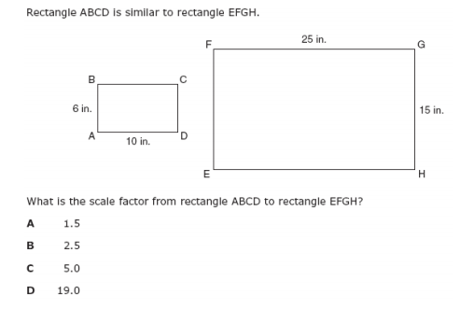

- Are the two figures scale figures? If not, explain why not. If so, determine the scale factor from the larger figure to the smaller figure.
__________________________________________________________________________________________________________________________________________________________________________________________________________________________________________________________________________________________

Master Level

- Figure A is inside Figure B on the coordinate plane below. Describe two different scale factors that could be used to describe the relationship between figure A and figure B.

Figure B

Figure A

_______________________________ ______________________________________

- Marshall determined that the two figures below were not scaled figures because the ratio of longest sides were $\frac{24}{8}$ = 3 and the ratio of the shortest sides were $\frac{4}{12} =\frac{1}{3}$. Do you agree with Marshall? Explain why or why not.

4 in.
24 in.

12 in. 8 in.

______________________________________________________________________________________________________________________________________________________________________________________________________________________________________________________________________________________________________________________________________________________________________________________________________________________________________________________________________________________
- A scale model of a car has a length of 12 inches. The actual car is 114 inches long. Write an equation that could be used to determine the actual length of any part of the car given model length. Use the variable a for actual measurement and s for scaled measurement.

______________________________________________________________________________________________
PhD Level

- On a blueprint for an apartment building, the height of the door is 4 inches tall. The actual door is 84 inches high. If the rest of the blueprint follows this exact same scale, what would be the actual dimensions of a room that is 10 inches long and 18 inches wide on the blueprint? Express your answer in terms of feet (12 inches = 1 foot).
Name: ______________________________ Date: _______________________
EXIT TICKET
Self-assessment | I mastered the learning objective today. | I am almost there. | Need more practice and feedback.
Teacher feedback | You mastered the learning objective today. | You are almost there. | You need more practice and feedback.

    - Is image 2 a scale drawing of Image 1? Prove and explain your reasoning. If they are scaled drawings, determine the scale factor from image 1 to image 2.

Image 1 Image 2
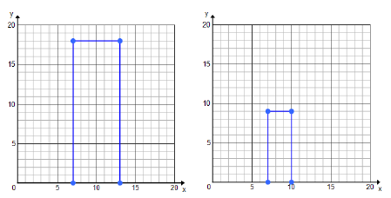
____________________________________________________________________________________________________________
________________________________________________________________________________________________________________________________________________________________________________________________________________________________________________________________________________________________________________________________________________________________________________________________________________________________________________________________________________________________________________________________________________________________________________________________________________________________________________
________________________________________________________________________________________________________________________________________________________________________________________________________________________________________________________________________________________________________________________

    - Is image 2 a scale drawing of Image 1? Prove and explain your reasoning. If they are scaled drawings, determine the scale factor from image 1 to image 2.

Image 1 Image 2






