Name: ___________________________ Date: ____________________________
UNIT 5 LESSON 14

AIM: SWBAT determine areas of scaled figures

THINK ABOUT IT!
Rectangle A had a scale factor of 3 applied to it to create Rectangle B. Use the scale factor to determine the area of Rectangle B.

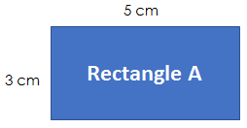

Rectangle B

Test the Conjecture 1) Circle B is created by applying a scale factor of ½ to Circle A. Determine the approximate area of Circle B using 3.14 for pi.

Circle A Circle B
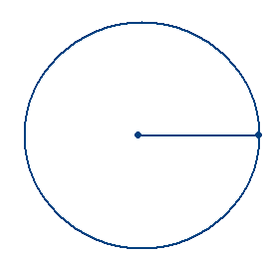

16mm

Test the Conjecture 2) The two triangles below are scaled figures. Determine the area of the larger triangle.
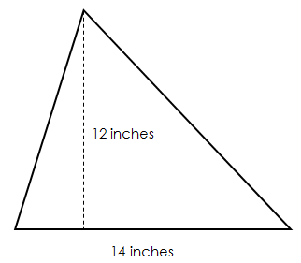
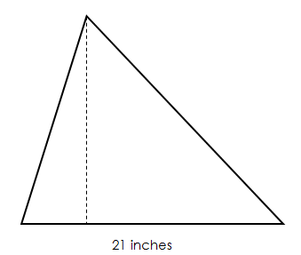

Conjecture

PARTNER PRACTICE

Bachelor Level

- The smaller square below is used to create the larger square by using a scale factor of 4. Determine the area of the larger square.

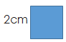

- Rectangle A is a ½ scale drawing of rectangle B. What is the area of rectangle A?

Rectangle A Rectangle B
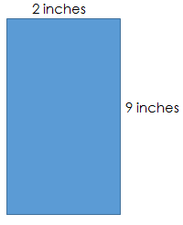

Master Level

- Determine the area of the smaller rectangle if the larger rectangle is a scale drawing of the smaller one.

1mm

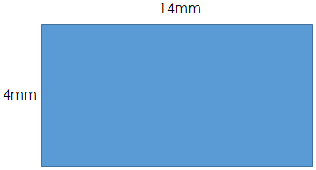

INDEPENDENT PRACTICE

Bachelor Level

- The area of a parallelogram can be found by multiplying the base times the height (a = bh). Use the diagram below to determine the area of the smaller parallelogram if a scale factor of $\frac{1}{3}$ is applied to the larger one to create it.
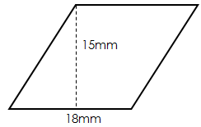

- Mark claims that he can multiply that area of Rectangle A by 4 to get the correct area of Rectangle B. Do you agree with him? Explain and prove your answer.

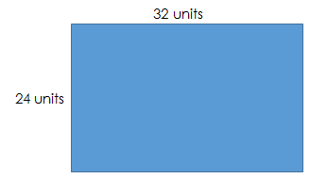
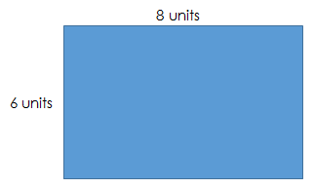

A
B

____________________________________________________________________________________________________________________________________________________________________________________________________________________________________________________________________________________________________________________________________________________________________________

Master Level

- A scale drawing of a circular pool measures 4 inches from one side to the other through the center. The scale of the drawing is 1inch = 5.5 feet. Read each statement below and determine whether you think the statement is “True” or “False.”

Statement | True | False
The diameter of the pool is 8 inches
The radius of the pool is 2 inches
To cover the pool, you would need a cover with an approximate area of 69.08 square feet
To cover the pool, you would need a cover with an approximate area of 379.94 square feet
The distance around the pool is approximately 69.08 feet

- The area of a trapezoid is a = ½ h(b₁ + b₂) where h is the height and b₁ and b₂ are the bases. Determine the area of the larger trapezoid if the two trapezoids are scaled figures.
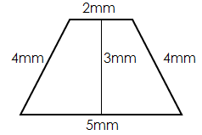
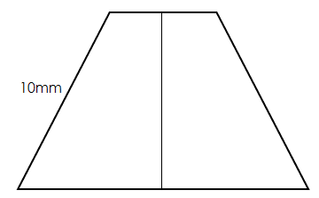

- Savannah used the scaled figures below to get an area of 135m² for the smaller triangle. Determine the correct area to determine what mistake did Savannah made while solving.
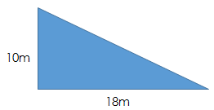

13.5m

____________________________________________________________________________________________________________________________________________________________________________________________________________________________________________________________________________________________________________________________________________________________________________

PhD Level

- Determine if a scale factor can be used to solve for the perimeter of a scaled figure using the rectangles below and applying a scale factor of 3 to the smaller rectangle.

7cm

3cm

- Explain why you think you got the answer you did and use it to explain why scale factor cannot be directly applied to area.

____________________________________________________________________________________________________________________________________________________________________________________________________________________________________________________________________________________________________________________________________________________________________________________________________________________________________
Name: ______________________________ Date: _______________________
EXIT TICKET
Self-assessment | I mastered the learning objective today. | I am almost there. | Need more practice and feedback.
Teacher feedback | You mastered the learning objective today. | You are almost there. | You need more practice and feedback.

- Square A has a side length of 6 cm. Square B is the resulting image after a scale factor of 2 has been applied to Square A. Shania says that the area of Square B is 2 times the area of Square A. Determine the area of Square B. Do you agree with Shania? Explain why or why not. If you disagree, describe the correct relationship between the two areas.

____________________________________________________________________________________________________________________________________________________________________________________________________________________________________________________________________________________________________________________________________________________________________________________________________________________________________________________________________________________________________________________________________________________________________________________

