Name: ___________________________ Date: ____________________________
UNIT 5 LESSON 15

AIM: SWBAT determine areas of scaled figures

THINK ABOUT IT!
The table below shows an original figure and its area, a scale factor, and the scaled figure. Determine the area of the scaled figures. What relationship do you see that exists between the scaled areas and the original areas?

Original Figure | Original Area | Scale Factor | Scaled Figure | Scaled Area
 | $$a=l×w$$  $$a=4 ×2$$  $$a={8in}^{2}$$ | 2 | 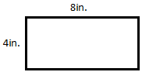
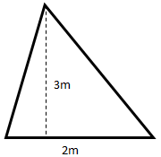 | $$a=\frac{1}{2}b×h$$  $$a=\frac{1}{2}(2)(3)$$  $$a=\frac{1}{2}(6)$$  $$a={3m}^{2}$$ | 3 | 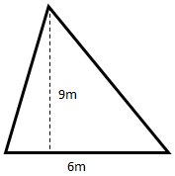
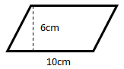 | $$a=b×h$$  $$a=10 ×6$$  $$a={60cm}^{2}$$ | c | 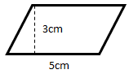  10c  6c

______________________________________________________________________________________________________________________________________________________________________________________________________________________________________________________________________________________________________
Test the Conjecture 1) A rectangle has an area of 54 square units. A scale factor of $\frac{1}{3}$ is applied to the rectangle to create a scaled figure. What is the area of the scaled figure?

9 units
54 Square Units

6 units
Area = ?

Test the Conjecture 2) Figure A has an area of 6 square units. Figure B was created by scaling Figure A and it has an area of 96 square units. What was the scale factor that was applied to Figure A to create Figure B?
96 units²

6 units²

4 units

3 units

Conjecture

PARTNER PRACTICE

Bachelor Level

- The area of a rectangle is 20 square feet. If a scale factor of 3 is applied to the rectangle to form a new rectangle, what will be its area?

- 60 square feet
- 120 square feet
- 180 square feet
- 40 square feet

- A square has an area of 10 square millimeters. If a scale factor of 3 is applied to the square, what is the area of the new square that is formed?

- Solve the problem below
Master Level
- On the blueprint for Joey’s new house, his floor measures 9 square feet. The actual house will have an area of 1,296 square feet. What scale factor must be applied to create the house from the blueprint?

INDEPENDENT PRACTICE

Bachelor Level

- Which equation could be used to determine the area of new figure when a scale factor of 4 is applied?
  - y = 4x
  - y = ¼ x
  - y = 16x
  - y = $\frac{1}{16}x$

- A rectangle has an area of 28 square inches. After a scale factor of $\frac{1}{2}$ is applied, what is the area of the new shape?

- Solve the problem below:
Master Level

- A toy racecar has a roof with an area of 20 square mm. The real car has a roof with an area of 2,420 square mm. What scale factor was applied to the model to create the car?

- A square has a side of $y$ inches. By applying a scale factor of 5, a new square is formed. Write an expression to represent the area of the new square.

- The third floor of the White House in Washington, D.C. has an area of 507 square feet. A model of the White House has an area of 432 square inches. What scale factor was applied to the actual White House to create the model?

PhD Level

- A drawing of a room shows the floor is 2” by 3”. For the actual room, a scale factor of 100 is applied. Family is tiling the room with 8” by 4” tiles. How many tiles should they buy?

Name: ______________________________ Date: _______________________
EXIT TICKET
Self-assessment | I mastered the learning objective today. | I am almost there. | Need more practice and feedback.
Teacher feedback | You mastered the learning objective today. | You are almost there. | You need more practice and feedback.

- A parallelogram has an area of 48 square millimeters. Jorge applied a scale factor of $\frac{1}{4}$ to produce a new parallelogram. What is the area of the new parallelogram?

- The area of triangle A is 20 square inches. The area of triangle B is 5 square inches. What scale factor was applied to triangle A to create triangle B?

