Name: ___________________________ Date: ____________________________
UNIT 5 LESSON 3

AIM: SWBAT apply the concept of the constant of proportionality to a table of values.

THINK ABOUT IT!
Tori is buying pumpkins and weighing the total amount as she goes (show in the table below). Given the table, determine the unit rate for each point in the table. What can you conclude about the table?

Number of Pumpkins | Total Weight (lbs) |  | Unit Rate
3 | 12
5 | 20
7 | 28
9 | 36
15 | 60

__________________________________________________________________________________________________________________________________________________________________________________________________________________________________________________________________________________________________________________________________________________________________________________________________________________________________________________________________________________________________________

Test the Conjecture #1) Does the table below represent a proportional relationship?

x | y
3 | 36
6 | 72
7 | 84
10 | 120
11 | 134

Test the Conjecture #2) The table below represents a proportional relationship. What values of n and m would keep the table proportional?

Input (x) | Output (y)
2 | 16
5 | 40
7 | m
n | 80
12 | 96

Conjecture

PARTNER PRACTICE

Bachelor Level

- The table below represents the relationship of the amount of snowfall (in inches) in 5 counties to the amount of time (in hours) hours of a recent winter storm. Does this represent a proportional relationship? Explain.

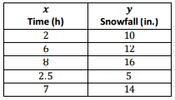

__________________________________________________________________________________________________________________________________________________________________________________________________________________________________________________________________________________________

- The table below shows the relationship between the cost of renting a movie (in dollars) to the number of days the movie is rented. Read each statement below the table and determine if it is true or false.

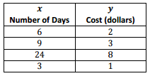

Statement | True | False
Dollars represents the independent variable

The relationship between the cost and the number of days is proportional because 6÷ 2 = 3 and 9 ÷ 3 = 3.

The relationship between the cost and the number of days is not proportional because the values do not increase in order
The relationship between the cost and the number of days is proportional because there is a CoP of $\frac{1}{3}$

Master Level
- Randy is planning to drive from New Jersey to Florida. Every time Randy stops for gas, he records the distance he traveled in miles and the total number of gallons used. Assume that the number of miles driven is proportional to the number of gallons consumed in order to complete the table.

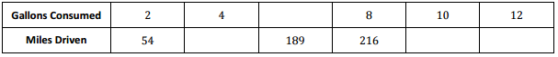
INDEPENDENT PRACTICE

Bachelor Level

- The table below shows the relationship between the amount of candy bought (in pounds) and the total cost of the candy (in dollars). Does this represent a proportional relationship? Explain.

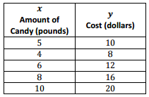

__________________________________________________________________________________________________________________________________________________________________________________________________________________________________________________________________________________________

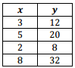
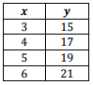
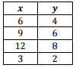
- Which of the following tables represent a proportional relationship? Circle all that apply.

Master Level

- Kayla made observations about the selling price of a new brand of coffee that sold in three different-sized bags. She recorded those observations in the following table:

Select all of the statements below that are true:

a) The price is proportional to the amount of coffee because the constant of proportionality is the same for each ratio
b) the price is proportional to the amount of coffee because there is a constant of proportionality of 0.35
c) A 20oz bag of coffee would cost $7
d) If you spend $4.20 you have purchased 10 ounces of coffee of a 20 oz. bag of coffee.

- Keisha and Dave or riding in a bike-a-thon. The tables below show distances they traveled. Do either of them travel at a proportional speed? Explain.
Keisha Dave
Hours | 0 | 2 | 4 | 5 | 7
Miles | 0 | 12 | 20 | 35 | 42
Hours | 0 | 3 | 6 | 8 | 9
Miles | 0 | 18 | 36 | 48 | 54

____________________________________________________________________________________________________________________________________________________________________________________________________________________________________________________________________________________________________________________________________________________________
5. The numbers of miles travelled in a car and amount of gas spent is proportional and represented in the table below. Fill in the missing values and use the table and constant of proportionality to determine how many gallons of gas are needed to travel 594 miles.

Miles |  | 135 |  | 189 |  | 270 |  | 405
Gas (gallons) | 3 | 5 | 6 |  | 9 |  | 12

6. The table below shows the relationship between the number of cars sold and the amount of money earned by the car salesperson. Is the amount of money earned, in dollars, proportional to the number of cars sold? Explain why or why not.

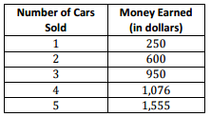

________________________________________________________________________________________________________________________________________________________________________________________________________________________________________________________________________________________________________________________________________________________________________________________

PhD Level

7. Make your own example of a relationship between two quantities that is NOT proportional. Describe the situation, and create a table to model it. Explain why one quantity is not proportional to the other.

____________________________________________________________________________________________________________________________________________________________________________________________________________________________________________________________________________________________________________________________________________________________________________________________________________________________________________________________________________________________________________________________________________________________________________________

- You have been hired by your neighbors to babysit their children on Friday night. You are paid $8 per hour. Complete the table relating your pay to the number of hours you worked. Is the pay proportional to the hours worked? How do you know?

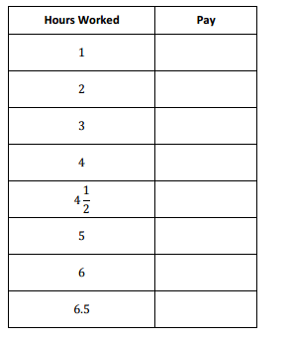
____________________________________________________________________________________________________________________________________________________________________________________________________________________________________________________________________________________________________________________________________________________________________________________________________________________________________________________________________________________________________________________________________________________________________________________
__________________________________________________________________________________________________________________________________________________________________________________________________________________________________________________________________________________________

Name: ______________________________ Date: _______________________
EXIT TICKET
Self-assessment | I mastered the learning objective today. | I am almost there. | Need more practice and feedback.
Teacher feedback | You mastered the learning objective today. | You are almost there. | You need more practice and feedback.

- The table below shows the price, in dollars, for the number of roses indicated.

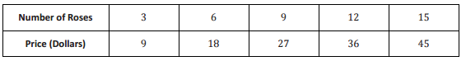

Part A: John says that the price is proportional to the number of roses because 9 ÷ 3 = 3 and 18 ÷ 6 = 3.
What is the error in John’s reasoning?

A) There is no error he is correct

B) The price is not proportional to the number of roses because he divided in the wrong order

C) In order for Jon to conclude that the price is proportional to the number of roses, he needs to find all of the unit rates

Part B: Is the price proportional to the number of roses? Explain how you know.

___________________________________________________________________________________________________________________________________________________________________________________________________________________________________________________________________________________________________________________________________________________________________________________________________________________________________________________
Part C: Determine the cost of 5 dozen roses (1 dozen = 12 roses)

