Name: ___________________________ Date: ____________________________
UNIT 5 LESSON 4

AIM: SWBAT apply the concept of the constant of proportionality to a table of values.

THINK ABOUT IT!
In the first three rows of the table below, the table is complete. For the final three rows, there are values missing. Determine if the table represents a proportional relationship in the first three row and then determine the missing values of the table.

Input | Output
1 | 4
3 | 12
5 | 20
7
 | 32
15

Key Point
Interaction with New Material
Below are two tables that describe the side lengths of a perfect square and their perimeter and area. Complete both the tables below and explain which table represents a proportional relationship and why.

Table A:
Side length (inches) | Perimeter (inches)
1 | 4
2
3
4
10
 | 80

Table B:
Side length (inches) | Area (square inches)
1 | 1
2 | 4
3
4
8
 | 144

____________________________________________________________________________________________________________________________________________________________________________________________________________________________________________________________________________________________________________________________________________________________________________________________________________________________________________________________________________________________________________________________________________________________________________________________________________

PARTNER PRACTICE

Bachelor Level

- The table below represents a proportional relationship. Determine the constant of proportionality and use it to fill in the missing values of the table.

Input | Output
3 | 6
4 | 8
5 | 10
6
 | 16
10
 | 60

- The table below shows the relationship between the side length of a pentagon and the perimeter. Complete the table. Then, determine if the length of the sides is proportional to the area.

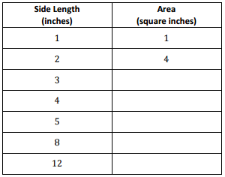
10
5
Perimeter (inches)

Master Level

- Mary is filling out a table to keep track of how much money is in her account. On first day of the month, she has $50. On the third day she has $150. On the 4th day, she has $200. If her account continues the same way, write an expression to determine how much money she will have on the 9th day and how long it will take her to have $n in her account.

Day | 1 | 3 | 4 | x
Account Balance |  |  |  |  | $n

INDEPENDENT PRACTICE

Bachelor Level

- Determine the constant of proportionality and use it to determine the missing values in the table. Explain how you used the CoP to determine the last missing value in the table.

Independent Variable | Dependent Variable
4 | 20
6 | 30
8 | 40
12
15
 | 100

____________________________________________________________________________________________________________________________________________________________________________________________________________________________________________________________________________________________________________________________________________________________
- Joseph earns $15 for every lawn he mows. Determine whether each statement below represents the relationship between how much he earns and how many lawns he mows. Choose “Yes” or “No.”

Statement | Yes | No
If Joseph mows 5 lawns, he will earn $75
If Joseph earns 30 lawns, he will earn $2
The relatinoship between the money he earns and the number of lawns he mows is proportional

Master Level

- Determine the missing values for the table that represents a proportional relationship. Explain how you determined your answer.

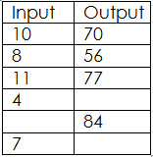
Table A Table B
Input | Output
1 | 5
3 | 6
5 | 7
 | 8
9
 | 10

________________________________________________________________________________________________________________________________________________________________________________________________________________________________________________________________________________________________________________________________________________________________________________________

- At the end of the summer, Caitlin had saved $120 from her summer job. This was her initial deposit into a new savings account at the bank. As the school year starts, Caitlin is going to deposit another $5 each week from her allowance. She thinks that her account balance proportional to the number of weeks of deposits. Use the table below and explain whether you agree or disagree with Caitlin.

________________________________________________________________________________________________________________________________________________________________________________________________________________________________________________________________________________________________________________________________________________________________________________________
- Lucas and Brianna read three books each last month. The table shows the number of pages in each book and the length of time it took to read the entire book.

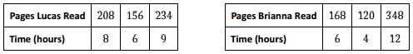

Step A: Which of the tables, if any, shows a proportional relationship?

________________________________________________________________________________________________________________________________________________________________________________________________________________________________________________________________________________________________________________________________________________________________________________________

- Mark recently moved to a new state. During the first month, he visited five state parks. Each month after, he visited two more. Complete the table below, and use the results to determine if the number of parks visited is proportional to the number of months.

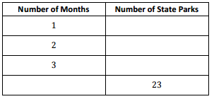

PhD Level

- You have decided to walk in a long-distance race. There are two teams that you can join. Team A walks at a constant rate of 2.5 miles per hour. Team B walks 4 miles the first hour and then 2 miles per hour after that. Task: Create a table for each team showing the distances that would be walked for times of 1, 2, 3, 4, 5, and 6 hours. Using your tables, answer the questions that follow

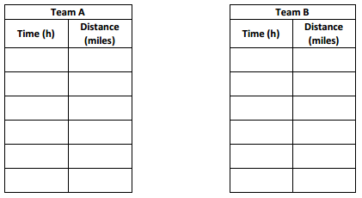

Step A: For which team is distance proportional to time? Explain why the other is not proportional.

_____________________________________________________________________________________________________________________________________________________________________________________________________________________________________________________________________

Step B: At what distance in the race would it be better to be on Team B than Team A?

Step C: Will there always be a winning team, no matter what the length of the course? Why or why not?

______________________________________________________________________________________________________________________________________________________________________________
______________________________________________________________________________________________________________________________________________________________________________

Step D: If the race is 12 miles long, how much sooner would you finish on the winning team compared to the other team?

Name: ______________________________ Date: _______________________
EXIT TICKET
Self-assessment | I mastered the learning objective today. | I am almost there. | Need more practice and feedback.
Teacher feedback | You mastered the learning objective today. | You are almost there. | You need more practice and feedback.

- The table below shows the relationship between the side lengths of a regular octagon and its perimeter.

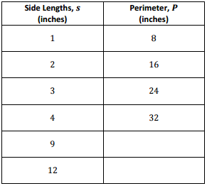

Step A: Complete the table

Step B: If Gabby wants to create a regular octagon with side lengths of 20, what will be the perimeter? Is the perimeter proportional to the perimeter? Justify your answer.

____________________________________________________________________________________________________________________________________________________________________________________________________________________________________________________________________________________________________________________________________________________________________________________________________________________________________________________________________________________________________________________________________________________________________________________

