Name: ___________________________ Date: ____________________________
UNIT 5 LESSON 5

AIM: SWBAT determine if values are proportional by graphing

THINK ABOUT IT!
Three tables with corresponding graphs are shown below. Table A represents a proportional relationship while Tables B and C do not. What criteria must the graph of a proportional relationship have?

Table A Table B Table C
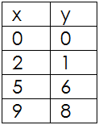
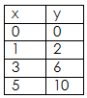
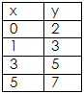

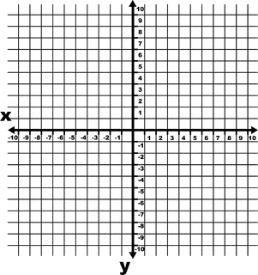

__________________________________________________________________________________________________________________________________________________________________________________________________________________________________________________________________________________________________________________________________________________________________________________________________________________________________________________________________________________________________________
Test the Conjecture #1) Do the points (2, 5), (1, 3), and (3, 7) represent a proportional relationship?

Test the Conjecture #2) The table shows the prices a bakery charges for doughnuts. Is the relationship between number of doughnuts and cost proportional?

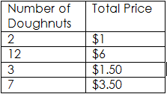
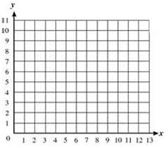

Conjecture

PARTNER PRACTICE

Bachelor Level

- Which of the following graphs represents a proportional relationship? Please circle it
- Explain why one the graphs you chose does not have a proportional relationship.
___________________________________________________________________________________________________________________________________________________________________________________________________________________________________________________________________________________

- Using the ratio provided, create a table that shows money received is proportional to the number of candy bars sold. Plot the points in your table on the grid.

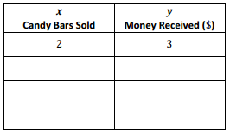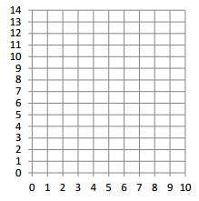

Master Level

- Isaiah sold candy bars to help raise money for his scouting troop. The table shows the amount of candy he sold compared to the money he received. Determine if this represents a proportional relationship or not and explain your answer.
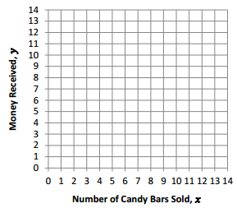
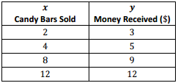

_______________________________________________________________________________________

______________________________________________________________________________________________

______________________________________________________________________________________________

______________________________________________________________________________________________

______________________________________________________________________________________________

INDEPENDENT PRACTICE

Bachelor Level

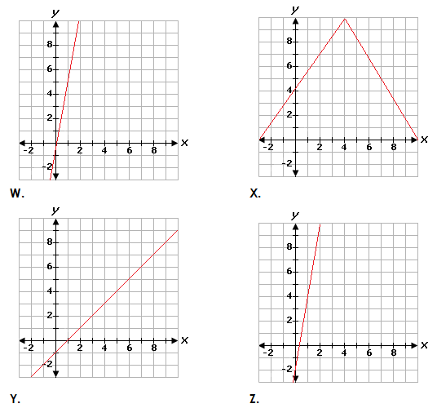
- Circle all the graphs that do not represent a proportional relationship.

- James says graph X represents a proportional relatinship because the lines are straght. Do you agree or disagree with this statement? Why?

________________________________________________________________________________________________________________________________________________________________________
________________________________________________________________________________________________________________________________________________________________________

- Graph the points in the table.

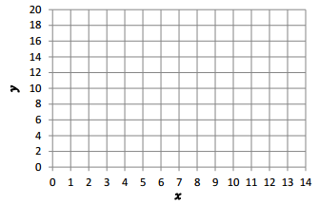
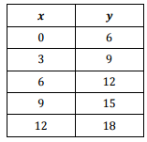

Read each statement below and decide, based on the graph whether it is true or false.

Statement | True | False
The constant of proportionality is 3
The relationship is proportional because the graph starts at the origin
The relationship is not proportional because there is no constant of proportionality
The relationship is not proportional because the graph does not form a straight line

aster Level

- A line passing through which of the following pairs of coordinates represents a proportional relationship? Graph each pair to determine if there is a proportional relationship.
(1, 3) and (3, 6)
(3, 6) and (4, 8)
(2, 5) and (4, 6)
(2, 4) and (5, 6)

- There is a different way you could have answered question #4 that would have been more efficient. Explain how else we could have determined whether the ordered pairs were in a proportional relationship.

_______________________________________________________________________________________________________________________________________________________________________________________________________________________________________________________________________________________________________________________________________________________________________________________________________________________________________________________________________

- A grocery store is offering a special on pineapple! The first five pineapples cost the regular price of $2.00. The next five only cost $1.00. The next five only cost $0.50. The price continues to be cut in half for every five you buy. (A store would normally have a max that you could buy ) Make a table or graph to determine if a proportional relationship exists. Explain your reasoning through your graph or table.
x | y

________________________________________________________________________________________________________________________________________________________________________________________________________________________________________________________________________________________________________________________________________________

PhD Level

- For the two tables below:
Step A: Graph the function to determine which table represents a proportional relationship.

Step B: For the proportional relationship, determine what the CoP is and describe how it is represented in the graph.

________________________________________________________________________________________________________________________________________________________________________________________________________________________________________________________________________________________________________________________________________________

Step C: For the non-proportional relationship, describe what you would have to do to all the points in the table to preserve linearity and shift the graph to pass through the origin.

________________________________________________________________________________________________________________________________________________________________________________________________________________________________________________________________________________________________________________________________________________
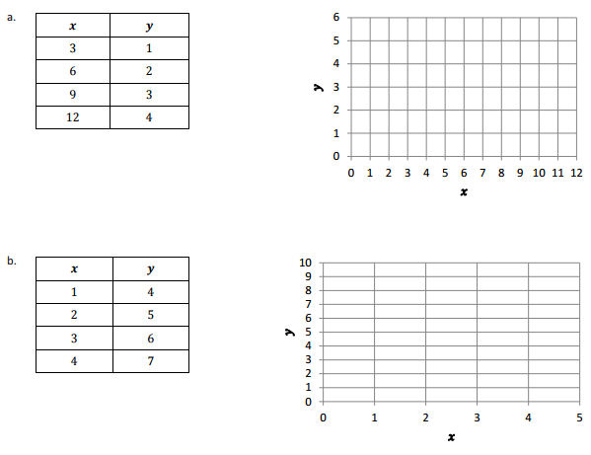

Name: ______________________________ Date: _______________________
EXIT TICKET
Self-assessment | I mastered the learning objective today. | I am almost there. | Need more practice and feedback.
Teacher feedback | You mastered the learning objective today. | You are almost there. | You need more practice and feedback.

- Does the table provided represent a proportional relationship? Prove and explain by calculating the unit rates and by graphing the relation.
x | y
1 | 3  __________________________________________________________________________________________________________________________________________________________________________________________________________________________________________________________________________________________________________________________________________________________________________________________________________________________________________________________________________________________________________________________________________
4 | 4
7 | 5
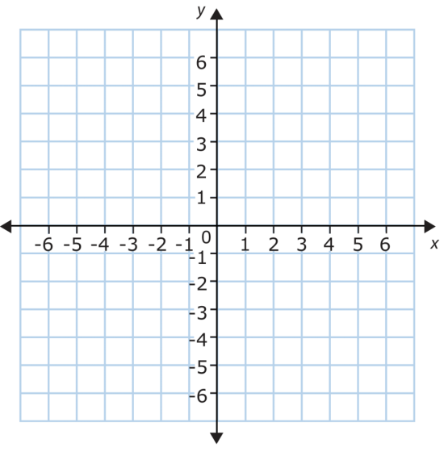

- Graph a proportional relationship that passes through the point (4, 2). Explain why the graph you drew represents a proportional relationship.
__________________________________________________________________________________________________________________________________________________________________________________________________________________________________________________________________________________________________________________________________________________________________________________________________________________________________________________________________________________________________________________________________________

