Name: ___________________________ Date: ____________________________
UNIT 5 LESSON 6

AIM: SWBAT determine if a graphed relationship is proportional

THINK ABOUT IT!
Verify that the graph below represents a proportional relationship using at least one strategy.

10 12 14 16 18 20 22 24 26 28 30

5 6 7 8 9 10 11 12 13 14 15

__________________________________________________________________________________________________
__________________________________________________________________________________________________
__________________________________________________________________________________________________
__________________________________________________________________________________________________
Test the Conjecture #1) Verify if this graph represents a proportional relationship.
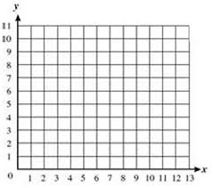

__________________________________________________________________________________________________
__________________________________________________________________________________________________
__________________________________________________________________________________________________
Test the Conjecture #2) The graph below shows the relationship y = |x| which produces straight lines and passes through the origin. Verify if this graph represents a proportional relationship.

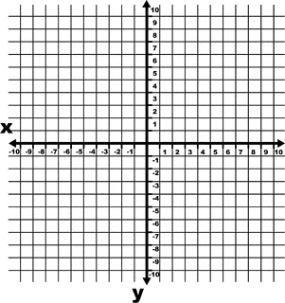

Conjecture

PARTNER PRACTICE

Bachelor Level

- Verify the graphed relationship is proportional using a table of values.
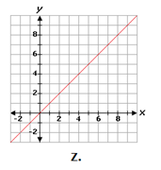

Explain: ______________________________________________________________________________
_______________________________________________________________________________________
_______________________________________________________________________________________
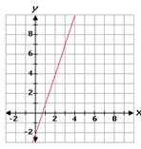
_______________________________________________________________________________________
- Part A: Create a table of values using points on the graph.

Part B: Choose the answer choice(s) below that correctly describes the graph. Select all that apply.

a) The graph represents a proportional relationship because the line is straight.
b) The graph does not represent a proportional relationship because the line does not pass through the origin
c) The graph does not represent a proportional relationship because the constant of proportionality is not the same for all points
d) The graph does not represent a proportional relationship because the unit rates are not the same for all points

Master Level

- Ms. Chibbaro says that the graph below represents a proportional relationship.
Do you agree or disagree with her claim? Explain.

_______________________________________________________________________________________
_______________________________________________________________________________________
_______________________________________________________________________________________
_______________________________________________________________________________________
_______________________________________________________________________________________
_______________________________________________________________________________________

INDEPENDENT PRACTICE

Bachelor Level

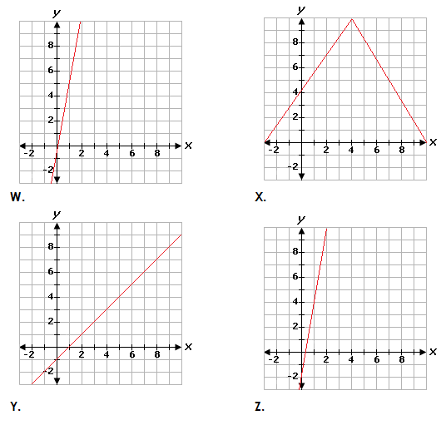
- Use the graphs below to determine if each statement below is “true” or “false.” Show your work.

Statement | True | False
Graph W represents a proportional relationship because the CoP is the same for each set of points
Graph X does not represent a proportional relationship because it does not pass through the origin
Graph Y represents a proportional relationship because the CoP is $\frac{2}{3}$
Graph Z does not represent a proportional relationship because the unit rate is not the same for each set of points

Master Level

Use the graph to answer questions 2 and 3.
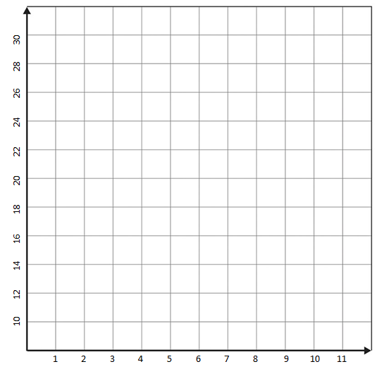

- Determine if the graphed function represents a proportion.

______________________________________________________________________________________________

______________________________________________________________________________________________

______________________________________________________________________________________________

- Lucy says that for every increase of 3 along the x-axis, the y value increases at a constant rate of 4. Because this happens at a constant rate and the graph passes through the origin, the function is proportional. Which of the following pieces of information best disproves her claim?

a) The line is straight

b) The line starts at the origin

c) The unit rate for point (3, 12) is 4 while the unit rate for point (6, 16) is $2\frac{2}{3}$

d) The unit rate for all points is 4

- Part A: Label the axes of graph A accordingly so that it represents a proportional relationship.
Part B: Label the axes of graph B so that it does not represent a proportional relationship.
Part C: Verify both graphs satisfy the criteria with tables and explain.
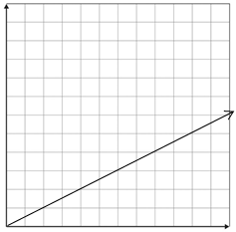
Graph A Graph B

____________________________________________________________________________________________________________________________________________________________________________________________________________________________________________________________________________________________________________________________________________________________________________
PhD Level

- Use the graph below to graph a proportional relationship. Verify your graph shows a proportional relationship and explain.

Name: ______________________________ Date: _______________________
EXIT TICKET
Self-assessment | I mastered the learning objective today. | I am almost there. | Need more practice and feedback.
Teacher feedback | You mastered the learning objective today. | You are almost there. | You need more practice and feedback.

- Prove that the following graph is proportional using a table of values.

- Jon says the following graph is proportional because for every increase in x, the y decreases constantly by 2. Prove and explain if Jon is right or wrong using a table.




