UNIT 5 LESSON 7

AIM: SWBAT represent proportions using equations

THINK ABOUT IT!
Part A: Given the table below, determine if the table represents a proportional relationship.

Independent Variable (x) | Dependent Variable (y)
3 | 9
5 | 15
7 | 21
10 | 30
11 | 33
6 | 18

Part B: If the relationship is proportional, use the constant of proportionality to write an equation that shows the relationship between x, y, and the constant of proportionality.

Equation: ____________________________________

Test the Conjecture #1) Tim’s salary is proportional and he earns $31 after 2 hours, $46.5 after three hours, and $62 after four hours. Write an equation that represents the amount of money Tim makes.

Test the Conjecture #2) Represent the graphed line as an equation
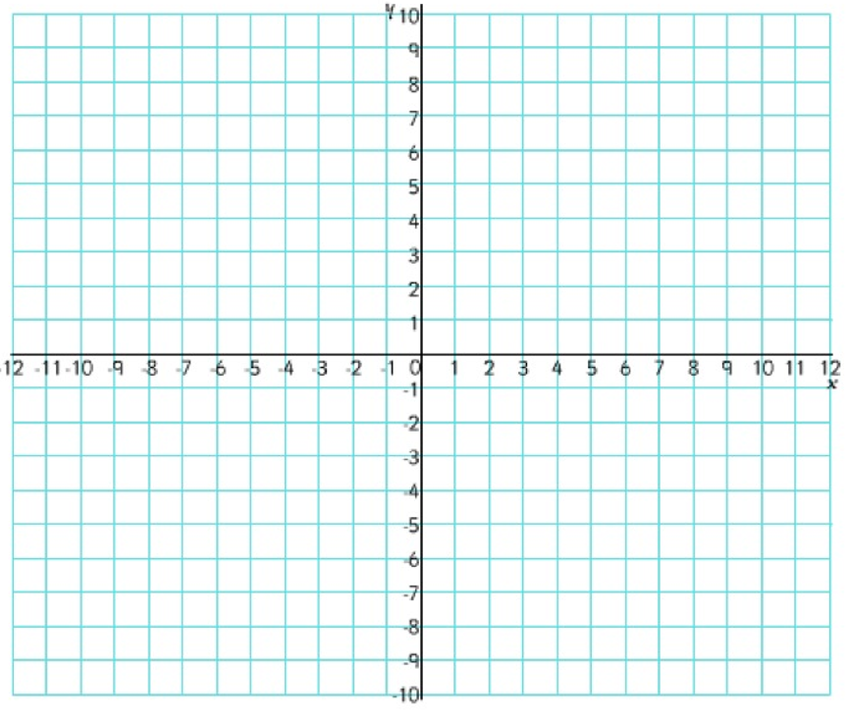

Conjecture

PARTNER PRACTICE

Bachelor Level

- Use the graph to determine which statements are correct. Select “yes” or “no,”

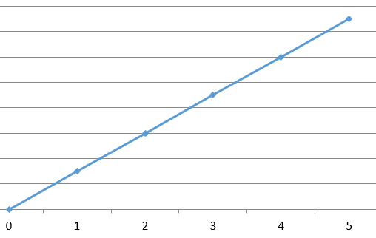
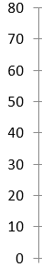

Amount Earned

Hours

Statement | Yes | No
The relationship is proportional because the line is straight and passess through the origin
The relationship is proportional because all of the CoPs are the same
The equation y = 30x represents this relationship
The equation y = 15x represents this relationship

- Joe’s paint company is making purple paint. The table below shows the amount of red paint to the amount of blue paint in the mixture. Write an equation that could be used to determine the number of cups of blue paint for any number of cups of red paint.
Cups of Red Paint | Cups of Blue Paint
0 | 0
1 | 4
2 | 8
3 | 12
4 | 16

Equation: _____________________

Master Level

- Part A: Imani decided to start working at the Boys and Girls club to make some extra money and support her community. The table below represents the amount of money she made per day ‘d.’ Write an equation that represents this table.

Day | Money
0 | 0
1 | 15
2 | 30
3 | 45
4 | 60

______________________________________

Part B: The graph below shows the amount of money Jamie makes per day, d, at the Boys and Girls club. Write an equation that shows the relationship of days worked and money earned.

____________________________________________

Part C: who earns more money after 8 days and by how much?

_______________________________________________

INDEPENDENT PRACTICE

Bachelor Level

- Use the table below to write an equation to represent the proportional relationship.

Hours | Miles Run
0 | 0
1 | 2
2 | 4
3 | 6
4 | 8
5 | 10

Step A: Equation: ____________________________

Step B: What does the equation mean in the context of the problem?

___________________________________________________________________________________________

___________________________________________________________________________________________

Step C: Show how you would check to see that your equation is correct:

- Which of the following equations could be used to show the relationship between number of days and amount of soda consumed? Select all that apply. Prove your answer is correct using points on the graph.
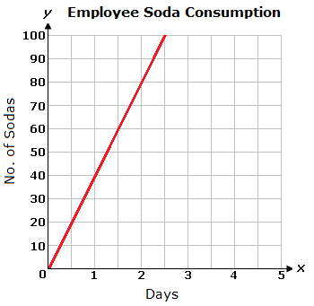
  - y = 20x
  - y = 40x
  - y = 2x
  - y = 4x
  - $\frac{y}{x}=40$
  - $\frac{x}{y}=40$

Master Level

- The New York Giants’ water boy is filling up their tank with water. The table below shows the amount of gallons of water ‘w’ that was in the tank after ‘m’ amount of minutes.
Minutes | Water (in gallons)
0 | 0
1 | 7
2 | 14
3 | 21
4 | 28

Step A: Write an equation to represent this table.

______________________________________
Step B: What does the ordered pair (2, 14) represent?

_______________________________________
Step C: Use your equation to determine the how many minutes it would take to completely fill the water tank if it can hold 56 gallons.

______________________________________

Step D: Eli Manning says that after 7 minutes the tank will have 49 gallons. Do you agree or disagree with his claim? Explain.

__________________________________________________________________________________________________

__________________________________________________________________________________________________

__________________________________________________________________________________________________

- Part A: Write an equation for each graph that shows the relationship between distance and time.

Graph A Graph B

Equation: ____________________________ Equation: _______________________________
Part B: Who is traveling at a faster rate?

__________________________________
Part C: How much farther will some go traveling at the faster rate for 2 days?

__________________________________

PhD Level

- The graph below shows the relationship between the number of rides someone can ride and the total cost for three different amusement parks.

Step A: Write three equations representing the three different amusement parks.

Busters: __________________________

Six Flags: __________________________

Coney: __________________________

Step B: Use your equations to determine how many rides you could ride by spending $5 at the park with the best value.

_________________________________________

Step C: How many more rides could you ride compared to the other parks?

___________________________________________
Name: ______________________________ Date: _______________________
EXIT TICKET
Self-assessment | I mastered the learning objective today. | I am almost there. | Need more practice and feedback.
Teacher feedback | You mastered the learning objective today. | You are almost there. | You need more practice and feedback.

- John and Amber work at two different ice cream shops. The table and graph below show how much money they make for how long they work.
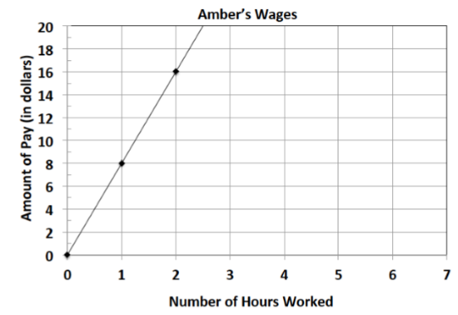
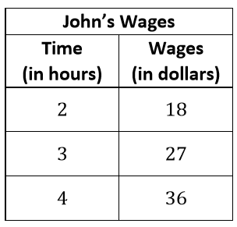

Step A: Write a separate equation for John and for Amber that describes how much money they make for a certain number of hours.

John: _________________________ Amber: _________________________

Step B: Which ice cream store pays more? Explain using the constant of proportionality.

______________________________________________________________________________________________________________________________________________________________________________________________________________________________________________________________________________________________________________________________________________________________________________________________________________________________________________________________________________________

