Name: ___________________________ Date: ____________________________
UNIT 6 LESSON 1

AIM: SWBAT convert between fractions, decimals, and percents

THINK ABOUT IT!
Use the 100’s grids to represent the percents visually and then write them as a decimal and fraction.
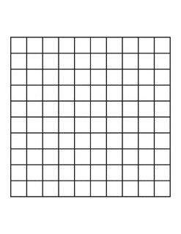
- 25%

- 125%

- 0.5%

Key Point

Interaction with New Material
Ex.1) Convert $3\frac{1}{8}$ into a percent and a decimal.

Ex.2) Write 0.8% as a fraction and as a decimal

PARTNER PRACTICE

Bachelor Level

- Color in the grids to represent the following fractions:
- $\frac{40}{100}$ | - $\frac{4}{100}$ | - $\frac{\frac{1}{4}}{100}$
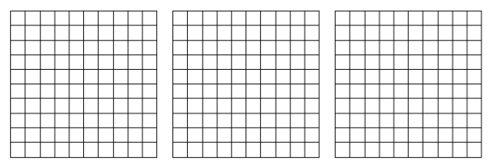

- Write each fraction as a decimal and percent using your model in question 1 to support your answer
- $\frac{40}{100}$ | - $\frac{4}{100}$ | - $\frac{\frac{1}{4}}{100}$

- Explain why your answer to part c makes sense.

________________________________________________________________________________________________________________________________________________________________________________________________________________________________________________________________________________________________________________________________________________________________________________________
Master Level

- Fill in the chart by converting between fractions, decimals, and percents. Show your work in the space below.
Fraction | Decimal | Percent
 |  | $$350\%$$
 | $$0.025$$
$$\frac{1}{8}$$

- Create a model to represent the following percents.
- $90\%$ | - $0.9\%$ | - $900\%$ | - $\frac{9}{10}\%$

INDEPENDENT PRACTICE

Bachelor Level

      - Use the definition of the word percent to write each percent as a fraction and then as a decimal.
Percent | Fraction | Decimal
$$37.5\%$$
$$100\%$$
$$110\%$$
$$1\%$$
$$\frac{1}{2}\%$$

      - Explain why your conversion of 110% makes sense with your given answers.

________________________________________________________________________________________________________________________________________________________________________________________________________________________________________________________________________________________________________________________________________________________________________________________

Master Level

      - Complete the table below by converting between fractions, decimals, and percents.

Fraction | Decimal | Percent
 |  | $$100\%$$
 | $$0.0825$$
 | $$6.25$$
 |  | $$\frac{1}{8}\%$$
$$\frac{2}{300}$$
 |  | $$33.3\%$$
$$\frac{\frac{3}{4}}{100}$$
 |  | $$250\%$$
 | $$0.005$$
$$\frac{150}{100}$$
 | $$0.055$$

      - Benjamin believes that$\frac{1}{2}\%$ is equivalent to $50\%$. Is he correct? Why or why not?

________________________________________________________________________________________________________________________________________________________________________________________________________________________________________________________________________________________________________________________________________________________________________________________
PhD Level

      - Order the following from least to greatest by converting all the values into the same representation.$100\%$,$\frac{1}{100}$,$0.001\%$,$\frac{1}{10}$, $0.001$, $1.1$,$10$, and$\frac{10,000}{100}$

- Use your knowledge of percents to match the given percents on the left with the verbal description of percents on the right.

$$25\%$$ | I am half of a half.  $5$ cubic inches of water filled in a $20$ cubic inch bottle.
$$50\%$$ | I am less than $\frac{1}{100}$.  $25$ out of $5,000$contestants won a prize.
$$30\%$$ | I am the chance of birthing a boy or a girl.  Flip a coin, and it will land on heads or tails.
$$1\%$$ | I am less than a half but more than one-fourth.  $15$ out of$50$play drums in a band.
$$10\%$$ | I am equal to $1$.  $35$ question out of $35$ questions were answered correctly.
$$100\%$$ | I am more than $1$.  Instead of the $\$1,200$ expected to be raised, $\$3,600$ was collected for the school’s fundraiser.
$$300\%$$ | I am a tenth of a tenth.  One penny is this part of one dollar.
$$\frac{1}{2}\%$$ | I am less than a fourth but more than a hundredth.  $\$11$ out of $\$110$ earned is saved in the bank.

Name: ______________________________ Date: _______________________
EXIT TICKET
Self-assessment | I mastered the learning objective today. | I am almost there. | Need more practice and feedback.
Teacher feedback | You mastered the learning objective today. | You are almost there. | You need more practice and feedback.

- Fill in the chart below by converting between fractions, decimals, and percents. Show work in the space provided.

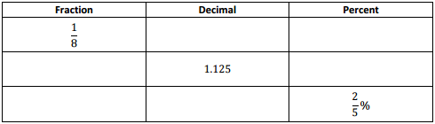

- Rachel says that 275% is equal to 2.75. Raymond says that’s not possible because 2.75 is greater than 1. Who do you agree with and why?

______________________________________________________________________________________________________________________________________________________________________________________________________________________________________________________________________________________________________________________________________________________________________________________________________________________________________________________________________________________

