Name: ___________________________ Date: ____________________________

UNIT 6 LESSON 16

**AIM**: SWBAT determine the area of scaled figures

**THINK ABOUT IT!**

Rectangle A had a scale factor of 50% applied to it to create Rectangle B. What is the area of Rectangle B?

8 cm

Rectangle A

AREA = 32sqcm

Rectangle B

AREA = ?

4 cm

Test the Conjecture #1) The area of drawing 1 is 20.25sqcm. What is the area of drawing 2 if a scale factor of 80% was applied to create it?

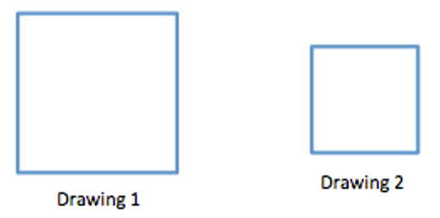

4.5 cm

Test the Conjecture #2) What percent of the area of the large square is the area of the small square?

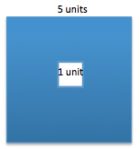

Conjecture

|  |
| --- |
|  |

**PARTNER PRACTICE**

|  |
| --- |
| *Bachelor Level* |

1. What is the area of a figure if it originally was 240sq units and had a 10% scale factor applied to it?
2. What is the area of the larger rectangle if it was created by applying a scale factor of 150% to the smaller rectangle?

Area = ?

Area = 34sqin

|  |
| --- |
| *Master Level* |

1. What percent of the area of the larger circle is shaded?

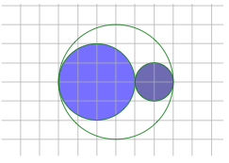

**INDEPENDENT PRACTICE**

|  |
| --- |
| *Bachelor Level* |

* + - 1. A triangle has an area of 48sqcm. A scale factor of 75% was applied to the triangle to create a new triangle. What is the area of the new triangle after the scale factor is applied?
      2. What percent of the area of the large disk lies outside the shaded disk? Determine the answer without calculating the areas of the circles.

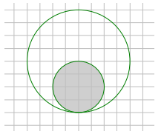

|  |
| --- |
| *Master Level* |

1. If the area of the shaded region in the larger figure is approximately $21.5$ square inches, write an equation that relates the areas using scale factor and explain what each quantity represents. Determine the area of the shaded region in the smaller scale drawing.

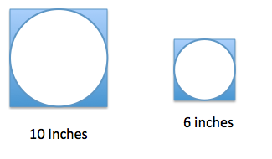

Equation: _____________________

Area shaded region (smaller square): _______________________

1. In the photo frame depicted below, three $5$ inch by $5$ inch squares are cut out for photographs. If these cut-out regions make up $\frac{3}{16}$ of the area of the entire photo frame, what are the dimensions of the photo frame?



1. The Lake Smith basketball team had a team picture taken of the players, the coaches, and the trophies from the season. The picture was $4$ inches by $6$ inches. The team decided to have the picture enlarged to a poster and then enlarged again to a banner measuring $48$ inches by $72$ inches.

Step A: Sketch drawings to illustrate the original picture and enlargements.

Step B: If the scale factor from the picture to the poster is $500\%$, determine the dimensions of the poster.

Step C: What scale factor is used to create the banner from the picture?

Step D: What percent of the area of the picture is the area of the poster? Justify your answer using the scale factor and by finding the actual areas.

|  |
| --- |
| *PhD Level* |

1. Use Figure 1 below and the enlarged scale drawing to justify why the area of the scale drawing is $k^{2}$ times the area of the original figure.

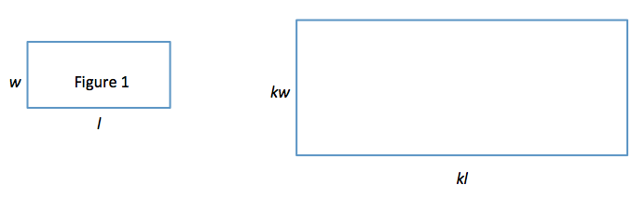

**________________________________________________________________________________________________________________________________________________________________________________________________________________________________________________________________________________________________________________________________________________________________________________________________________________________________________________________________________________________________________________________________________________________________________________________________________________________________________________**

1. Explain why the expressions $(kl)(kw)$ and $k^{2}lw$ are equivalent. How do the expressions reveal different information about this situation?

**________________________________________________________________________________________________________________________________________________________________________________________________________________________________________________________________________________________________________________________________________________________________________________________________________________________________________________________________________________________________________________________________________________________________________________________________________________________________________________**

**Name: ______________________________ Date: _______________________**

**EXIT TICKET**

|  |  |  |  |
| --- | --- | --- | --- |
| Self-assessment | I mastered the learning objective today. | I am almost there. | Need more practice and feedback. |
| Teacher feedback | You mastered the learning objective today. | You are almost there. | You need more practice and feedback. |

1. The area of a square is 12 square units. Juan applied a scale factor of 15% to create a new square. What is the area of the new square?
2. The larger rectangle was used to create the scale drawing (smaller rectangle). What percent of the larger area is the smaller area?

