Name: ___________________________ Date: ____________________________

UNIT 7 LESSON 1

**AIM**: SWBAT estimate the likelihood of an event occurring.

**THINK ABOUT IT!**

Use the spinner below for each of the following questions. Place an “x” along the number line to represent how likely the event is to occur.

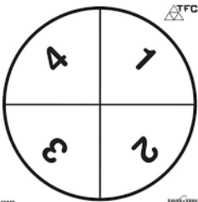

How likely is it for the spinner to land on a 5?

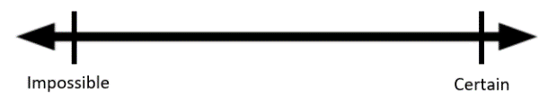

How likely is it for the spinner to land on 1, 2, 3, or 4?



How likely is it for the spinner to land on an even number?



How likely is it for the spinner to land on 1?



Key Point:

|  |
| --- |
|  |

**Interaction with New Material**

Ex.1) Mark stands at an intersection and observes if cars go left, right, or straight. After watching for a while, he recorded that 10 cars went straight, 4 cars went left and 6 went right. Estimate the probability that the next car goes left.

Ex.2) A scholar brought a jar of jellybeans to schools. The scholars picked out jellybeans one at a time and recorded the color of the jellybeans in the table below. Estimate the probability as a percent of randomly selecting a red jellybean from the jar.

|  |  |
| --- | --- |
| Jellybean Color | Number Picked |
| Green | 8 |
| Blue | 10 |
| Red | 30 |
| Yellow | 12 |

**PARTNER PRACTICE**

|  |
| --- |
| *Bachelor Level* |

1. Below are three different spinners. On which spinner is the green **likely** to win, **unlikely** to win, and **equally likely** to win?

|  |  |  |
| --- | --- | --- |
|  |  |  |

___________________ _________________ ______________________

1. Decide if each of the following events is *impossible*, *unlikely*, *equally likely to occur or not occur*, *likely*, or *certain* to occur.
   1. A vowel will be picked when a letter is randomly selected from the word *lieu*.
   2. A blue cube will be drawn from a bag containing only five blue and five black cubes.
   3. A red cube will be drawn from a bag of $100$ red cubes.
   4. A red cube will be drawn from a bag of $10$ green and $90$ blue cubes*.*

|  |
| --- |
| *Master Level* |

1. A student brought a very large jar of animal crackers to share with students in class. Rather than count and sort all the different types of crackers, the student randomly chose $20$ crackers and found the following counts for the different types of animal crackers. Estimate the probability of selecting a zebra. Express your answer as a fraction, decimal, and a percent.

|  |  |
| --- | --- |
| **Animal** | **Number Selected** |
| Lion | $$2$$ |
| Camel | $$1$$ |
| Monkey | $$4$$ |
| Elephant | $$5$$ |
| Zebra | $$3$$ |
| Penguin | $$3$$ |
| Tortoise |  |
|  | Total |

4. Draw a design for a spinner so that the probability of spinning a green is 1.

**INDEPENDENT PRACTICE**

|  |
| --- |
| *Bachelor Level* |

* + - 1. Decide where each event would be located on number line below. **Place the letter for each event in the appropriate place on the probability scale.**

Event:

1. You will see a live dinosaur on the way home from school today.
2. A solid rock dropped in water will sink.
3. A round disk with one side red and the other side yellow will land yellow side up when flipped.
4. A spinner with four equal parts numbered $1$– $4$ will land on the $4$ on the next spin.
5. Your full name will be drawn when a full name is selected randomly from a bag containing the full names of all of the students in your class.
6. A red cube will be drawn when a cube is selected from a bag that has five blue cubes and five red cubes.
7. Tomorrow the temperature outside will be $-250$ degrees.

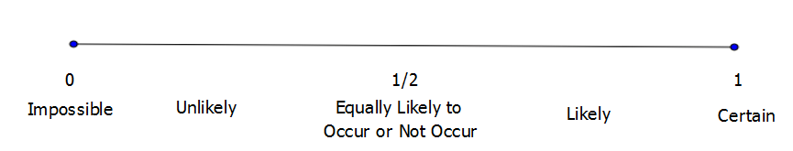

* + - 1. Explain how you determined where to put letter e.

____________________________________________________________________________________________________________________________________________________________________________________________________________________________________________________________________________________________________________________________________________________________

|  |
| --- |
| *Master Level* |

* + - 1. A seventh-grade scholar surveyedclassmates at her school. She asked them to name their favorite pets. Below is a bar graph showing the results of the survey.

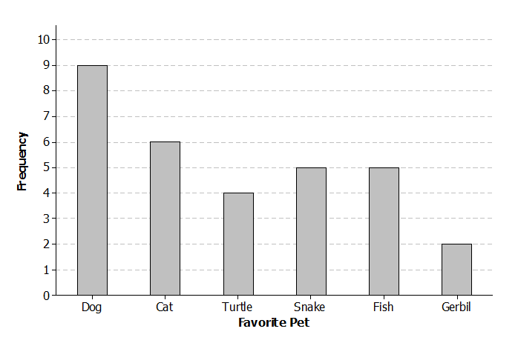

Step A: What is your estimate for the probability of the next student saying that a dog is their favorite pet? Express your answer as a decimal.

Step B: What is your estimate for the probability of the next student saying that a gerbil is their favorite pet? Express your answer as a simplified fraction

Step C: What is your estimate for the probability of the next student saying that a frog is their favorite pet? Express your answer as a percent.

1. Explain why your answer for Part C makes sense.

__________________________________________________________________________________________________________________________________________________________________________________________________________________________________________________________________________________________

1. A seventh-grade student conducted a survey at her school. She asked them how many hours a week they spend playing a sport or game outdoors. The results are listed in the table below.

|  |  |  |
| --- | --- | --- |
| **Number of Hours** | **Tally** | **Frequency** |
|  | | | | |  |
|  | | | | | |  |
|  | ~~| | | |~~ |  |
|  | ~~| | | |~~ | | |  |
|  | | | | |  |
|  |  |  |
|  | | | |  |
|  |  |  |
|  | | |  |

Use the table to estimate the probabilities below for the next student she surveys. Express you answer as a fraction, decimal, and percent.

Step A: What is your estimate for the probability of that student answering $3$ hours?

Step B: What is your estimate for the probability of that student answering $8$ hours?

Step C: What is your estimate for the probability of that student answering $6$ or more hours?

Step D: What is your estimate for the probability of that student answering $3$ or fewer hours?

Step E: If another $25$ students were surveyed, do you think they would give the exact same results? Explain your answer.

______________________________________________________________________________________________________________________________________________________________________________________________________________________________________________________________________________

Step F: If there are $200$ students at the school, what is your estimate for the number of students who would say they play a sport or game outdoors $3$ hours per week? Explain your answer.

______________________________________________________________________________________________________________________________________________________________________________________________________________________________________________________________________________

|  |
| --- |
| *PhD Level* |

1. A student played a game using one of the spinners below. The table shows the results of $15$ spins. Which spinner did the student use? Give a reason for your answer.

|  |  |  |  |  |  |  |  |  |  |  |  |  |  |  |  |  |  |  |  |  |  |  |  |  |  |  |  |  |  |  |  |  |  |
| --- | --- | --- | --- | --- | --- | --- | --- | --- | --- | --- | --- | --- | --- | --- | --- | --- | --- | --- | --- | --- | --- | --- | --- | --- | --- | --- | --- | --- | --- | --- | --- | --- | --- |
| |  |  | | --- | --- | | **Spin** | **Results** | |  |  | |  |  | |  |  | |  |  | |  |  | |  |  | |  |  | |  |  | |  |  | |  |  | |  |  | |  |  | |  |  | |  |  | |  |  | | ____________________________________________________________________________________________________________________________________________________________________________  ______________________________________________________________________________________  ______________________________________________________________________________________  ______________________________________________________________________________________  ______________________________________________________________________________________ |

**Name: ______________________________ Date: _______________________**

**EXIT TICKET**

|  |  |  |  |
| --- | --- | --- | --- |
| Self-assessment | I mastered the learning objective today. | I am almost there. | Need more practice and feedback. |
| Teacher feedback | You mastered the learning objective today. | You are almost there. | You need more practice and feedback. |

1. Decide where each of the following events would be located on the scale below. Draw an arrow from each event to the appropriate place on the probability scale.

***The numbers from 1 to 10 are written on small pieces of paper and placed in a bag. A piece of paper will be drawn from the bag.***

|  |  |  |  |  |  |  |  |  |
| --- | --- | --- | --- | --- | --- | --- | --- | --- |
| a) A piece of paper with a 5 is drawn from the bag. |  | b) A piece of paper with an even number is drawn. |  | c) A piece of paper with a 12 is drawn. |  | d) A piece of paper with a number other than 1 is drawn. |  | e) A piece of paper with a number divisible by 5 is drawn |

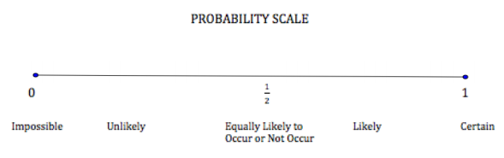

1. The table below shows the number of each type of crayon sitting in a bag. What is the estimate for the probability of selecting a blue crayon from the bag without looking? Express your answer as a fraction, decimal, and percent.

