Name: ___________________________ Date: ____________________________
UNIT 7 LESSON 10

AIM: SWBAT determine the probability of an independent compound event

THINK ABOUT IT!
What is the probability of flipping a coin and it landing on heads? ___________

What is the probability of the spinner (shown below) landing on 2? ____________

Below is a tree diagram of flipping a coin and spinning a spinner. Use the tree diagram to determine the probability of landing on heads and spinning a 2.

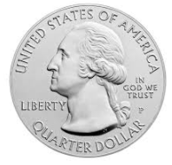
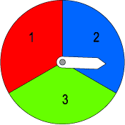

Flip Heads Flip Tails

Spin 1 Spin 2 Spin 3 Spin 1 Spin 2 Spin 3

Is there an easier way? Explain.

______________________________________________________________________________________________________________________________________________________________________________________________________________________________________________________________________________________________________

Test the Conjecture #1) What is the probability of spinning a 1 or 2 on the spinner and rolling a 1, 2, or 3 with the four-sided die?

Test the Conjecture #2) Your friend says he bets that you can’t flip a coin three times in a row and it land on heads every time. He will give you ten total tries (during each try you will get to flip the coin three times). Should you take the bet?

Conjecture

PARTNER PRACTICE

Bachelor Level

Use the spinner, coin, and number cube to answer the following questions.
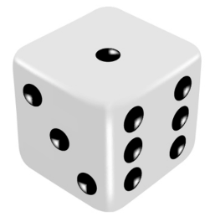
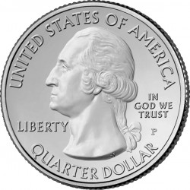
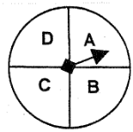

- Determine the probability of flipping a coin and it landing on heads and rolling the number cube and it landing on 4.

- Determine the probability of the spinner landing on D and the number cube landing on 2.

- Determine the probability of the coin landing on heads, the spinner landing on A and the number cube landing on either 1, 2, or 3.

Master Level

- Mary is creating a Valentine’s Day card for her friend and can choose from white, red, or pink construction paper to create a heart. On the heart, she can use black, blue, or green marker to write out her message and she can finish the valentine by sprinkling gold or silver glitter. What is the probability that her valentine to her friend will be on either red or pink construction paper with black marker and gold glitter?

INDEPENDENT PRACTICE

Bachelor Level

Use the coin, spinner and pile of cards below to answer questions 1-3.

- What is the probability of the spinner landing on 2 and randomly picking an “R” from the pile of cards shown below?
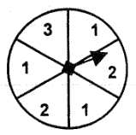
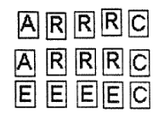

- Which expression(s) below could be used to find the the probability of the spinner landing on 3 twice, and flipping a coin and it landing on tails? Select al that apply.
a) $\frac{1}{3}x\frac{1}{2}$

b) $\frac{1}{3}x\frac{1}{3}x\frac{1}{2}$

c) $\frac{1}{3}x\frac{1}{3}$

d) $\frac{1}{9}x\frac{1}{2}$

- What is the probability of a coin landing on heads, the spinner not landing on 2, and not picking a vowel from the cards in question 1?

Master Level

- The Sandwich Shoppe allows people to pick one of each item to create their own sandwich.

Bread | Meat | Cheese | Condiment
Rye  White  Wheat | Ham  Chicken  Turkey | American  Provolone  Swiss  Munster | Mustard  Mayo

They ran out of Swiss and American cheeses as well as ham. What is the probability that someone will order a sandwich that they will be able to create?

- List the situations from least likely to most likely to occur:
  - The spinners landing on A, 1, and Brown
  - The spinners landing on D or B, 2, and Orange
  - The spinners landing on a vowel, not 3, and Pink
  - The spinners landing on E, 1 or 2, and Brown
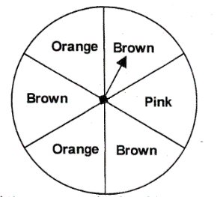

PhD Level

- A bag of marbles is being used for a probability experiment. There are 3 red marbles and 7 green marbles.

Step A: What is the probability of randomly pulling on a green marble?

Step B: What is the probability of pulling out a red marble if the green marble in Step A was not replaced?

Step C: What is the probability of pulling out a green marble if the marbles in the previous steps were not replaced?

Step D: The marbles were replaced and the experiment was started over. What is the probability of someone pulling on a green marble, not replacing it, and pulling out another green marble? Explain.

____________________________________________________________________________________________________________________________________________________________________________________________________________________________________________________________________________________________________________________________________________________________________________
Name: ______________________________ Date: _______________________
EXIT TICKET
Self-assessment | I mastered the learning objective today. | I am almost there. | Need more practice and feedback.
Teacher feedback | You mastered the learning objective today. | You are almost there. | You need more practice and feedback.

            - What is the probability that a flipped coin will land on heads and a six-sided number cube will land on a number greater than 2? Express your answer as a percentage.

Ice Cream Flavors | Cold Toppings | Hot Toppings
Chocolate  Vanilla  Coffee  Cookie dough  Mint chocolate chip  Coffee | Snickers  Sprinkles  Butterfinger  Blueberries  Strawberries  Reeses  M & Ms  Raspberries | Hot fudge  Hot caramel sauce
            - Tiyana is back at the ice-cream shop! What is the probability that Tiyana randomly selects an ice-cream sundae that is chocolate or vanilla, has sprinkles or Reeses, and has caramel sauce?
a) 96

b) $\frac{19}{24}$

c) $\frac{4}{96}$

d) $\frac{1}{96}$

