Name: ___________________________ Date: ____________________________

UNIT 7 LESSON 2

**AIM**: SWBAT determine is a situation represents uniform or non-uniform probability

**THINK ABOUT IT!**

You and your friend have a candy bar and decide to spin the spinner below to determine who gets the spinner. Which situation would you rather bet on so that you win the candy bar? Explain using probability.

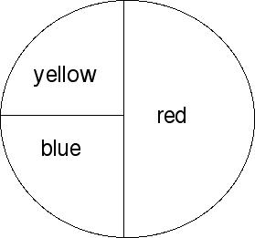

**Situation A**: You pick yellow and your friend picks blue

**Situation B**: You pick yellow and your friend picks red

__________________________________________________________________________________________________________________________________________________________________________________________________________________________________________________________________________________________________________________________________________________________________________________________________________________________________________________________________________________________________________

Key Point:

|  |
| --- |
|  |

**Interaction with New Material**

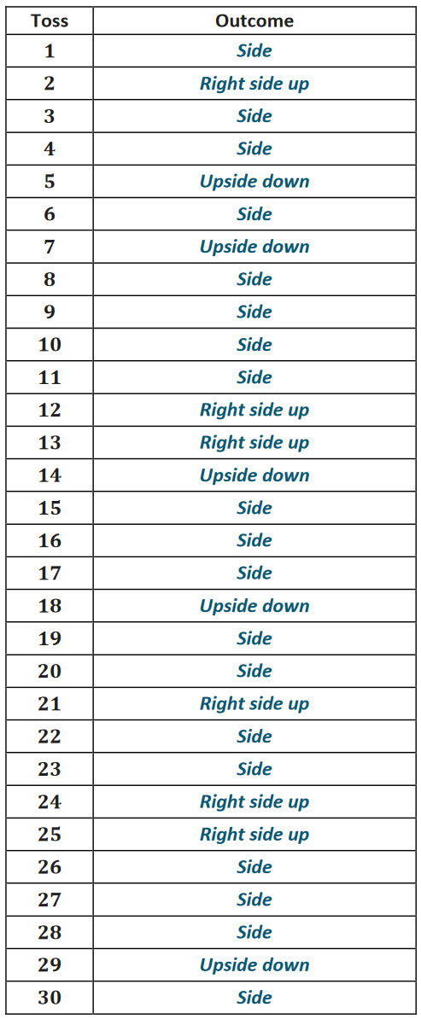Ex.1) A paper cup is being flipped in the air trying to get it to land right side up or upside down (not on its side) like the water bottle challenge. A scholar attempted flipping the cup 30 times (we call each of these **trials**) and recorded the outcomes in the table provided. Use the table provided to determine the observed relative frequency for each result and explain if this represents uniform or non-uniform probability.

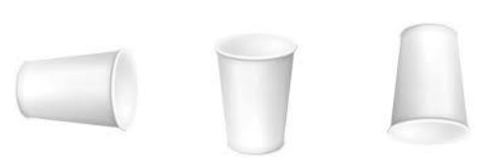

**__________________________________________________________________________________________________________________________________________________________________________________________________________________________________________________________________________________________________________________________________________________________________________________________________________________________________________________________________________________________________________**

**PARTNER PRACTICE**

|  |
| --- |
| *Bachelor Level* |

1. List the sample space for the following situations:
2. Drawing a colored cube from a bag with 2 green, 1 red, 10 blue, and 3 black cubes.
3. Tossing an empty soup can to see how it lands
4. Shooting a free throw in a basketball game
5. Shade the squares below so that it would represent uniform probability of randomly selecting a shaded or non-shaded square.
6. Calculate the probabilities for selecting a shaded or non-shaded square based on your model in question 2.

|  |
| --- |
| *Master Level* |

1. The diagram below shows a spinner designed like the face of a clock. The sectors of the spinner are colored red (R), blue (B), green (G), and yellow (Y).

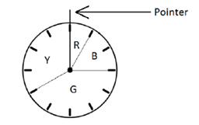

1. Write your answer as fractions in lowest terms and find the probability that the pointer stops on:
   1. Red
   2. Blue
   3. Green
   4. Yellow
2. What type of probability describes the model? How do you know?

____________________________________________________________________________________________________________________________________________________________________________________________________________________________________________________________________________________________________________________________________

**INDEPENDENT PRACTICE**

|  |
| --- |
| *Bachelor Level* |

1. List the sample space for the following situations:
2. Rolling a number cube with the numbers 1-6 on its faces.
3. Selecting a letter from the word *probability*
4. Spinning the spinner

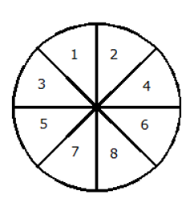

1. Shade the squares below so that it would represent non-uniform probability of randomly selecting a shaded or non-shaded square with it being more likely to select a non-shaded square.
2. Determine the probabilities for selecting a shaded and non-shaded square and use the probabilities to explain why your model represents non-uniform probability.

________________________________________________________________________________________________________________________________________________________________________________________________________________________________________________________________________________________________________________________________________________________________________________________

|  |
| --- |
| *Master Level* |

1. Which of the follow scenarios represents uniform probability? Select all that apply.
   1. Rolling a $1$ or a $2$ when a $6$-sided number cube with the numbers $1$– $6$ on the faces of the cube is rolled
   2. Selecting the letter *a* or *k* from the word *take*
   3. Selecting a black or an orange marble from a bag containing $50$ black and $45$ orange marbles
   4. Selecting a $4$ or an $8$ from the even numbers $2$– $14$, including and

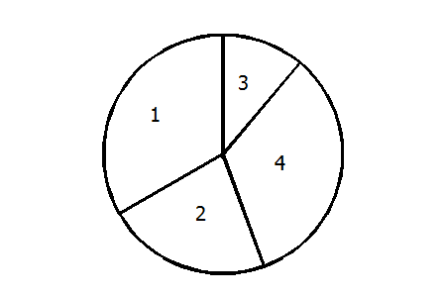

* 1. Landing on a $1$ or a $3$ when spinning the spinner

Choose one answer choice that you selected and explain why it is an example of uniform probability.

________________________________________________________________________________________________________________________________________________________________________________________________________________________________________________________________________________________________________________________________________________________________________________________

1. Wayne asked every student in his class how many siblings (brothers and sisters) they had. Survey results are shown in the table below. (Wayne included himself in the results.)

|  |  |  |  |  |  |
| --- | --- | --- | --- | --- | --- |
| Number of Siblings | $$0$$ | $$1$$ | $$2$$ | $$3$$ | $$4$$ |
| Number of Students | $$4$$ | $$5$$ | $$14$$ | $$6$$ | $$3$$ |

(Note: The table tells us that $4$ students had no siblings, $5$ students had one sibling, $14$ students had two siblings, and so on.)

* 1. How many students are there in Wayne’s class, including Wayne?
  2. What is the probability that a randomly selected student does not have any siblings? Write your answer as a fraction in lowest terms.
  3. The table below shows the possible number of siblings and the probabilities of each number. Complete the table by writing the probabilities as fractions in lowest terms.

|  |  |  |  |  |  |
| --- | --- | --- | --- | --- | --- |
| Number of Siblings | $0$ | $1$ | $2$ | $3$ | $4$ |
| Probability |  |  |  |  |  |

* 1. Writing your answers as fractions in lowest terms, find the probability that the student
     1. Has fewer than two siblings.
     2. Has two or fewer siblings.
     3. Does not have exactly one siblings

|  |
| --- |
| *PhD Level* |

1. Draw a spinner that has $3$ sections that are equally likely to occur when the spinner is spun. How many times do you think the spinner will land on each section after $100$ spins?
2. 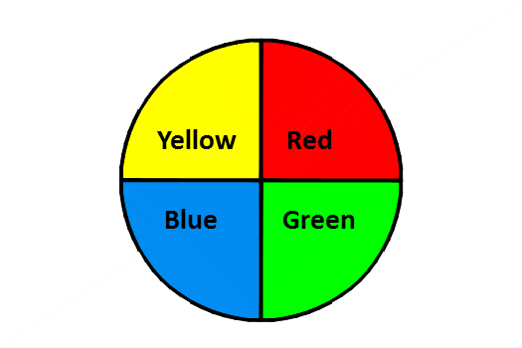You are playing a game using the spinner below. The game requires that you spin the spinner twice. For example, one outcome could be yellow on the 1st spin and red on the 2nd spin. List the sample space (all the possible outcomes) for the two spins.

**Name: ______________________________ Date: _______________________**

**EXIT TICKET**

|  |  |  |  |
| --- | --- | --- | --- |
| Self-assessment | I mastered the learning objective today. | I am almost there. | Need more practice and feedback. |
| Teacher feedback | You mastered the learning objective today. | You are almost there. | You need more practice and feedback. |

The numbers 1-10 are written on index cards, mixed up, and placed face down on a table. Use this situation to answer the following questions:

1. Describe the sample space for this situation.

_______________________________________________________________________________________

1. Do the events selecting an even number and selecting an odd number represent a situation with uniform or non-uniform probability? Explain.

______________________________________________________________________________________________________________________________________________________________________________

_____________________________________________________________________________________________________________________________________________________________________________________________________________________________________________________________________

1. Which events below represent situations with non-uniform probabilities? Select all that apply.

a) Selecting a number that is divisible by 3 and selecting a number divisible by 5

b) Selecting 1 and selecting 10

c) Selecting a prime number and selecting a composite number

d) Selecting a number less than 5 and selecting a number more than 6