Name: ___________________________ Date: ____________________________
UNIT 7 LESSON 5

AIM: SWBAT compare the values of theoretical probability and observed relative frequency

THINK ABOUT IT!
Conduct a probability experiment of flipping a coin and recording if it lands on heads or tails for 20 trials.

Trial | Result (heads or tails)
1
2
3
4
5
6
7
8
9
10
11
12
13
14
15
16
17
18
19
20

Determine the observed relative frequency of the coin landing on heads after the first trial, 5th trial, 10th trial, and 20th trial.

Trial | 1st | 5th | 10th | 20th
Observed Relative Frequency

What can you say about the observed relative frequency you calculated and the theoretical probability of a coin landing on heads?

______________________________________________________________________________________________________________________________________________________________________________________________________________________________________________________________________________________________________

Test the Conjecture:
A spinner with three equal sections is being used in a chance experiment. Predict the observed relative frequency of the spinner landing on blue if the spinner is spun 100 times. Conduct the experiment using online tools and record the frequency and observed relative frequency for the number of trials indicated in the table. Graph your results.

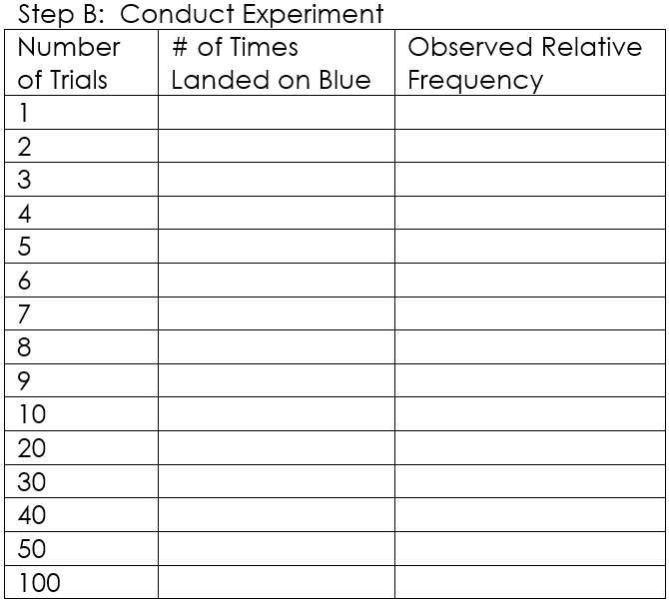
Step A: Prediction
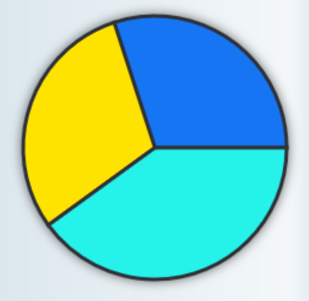

Step C: Graph Results
100%
90%

80%

70%

Observed Relative Frequency of Spinning Blue
60%
60%
50%

40%

30%

20%

10%

1 2 3 4 5 6 7 8 9 10 20 30 40 50 100
Number of Trials (note – scale is not consistent past 10 trials)

Conjecture:
PARTNER PRACTICE

Bachelor Level

            - The graph below shows the observed relative frequencies of a chance experiment after a certain number of trials. Without knowing anything about the experiment, what do you know about the theoretical probability of a success in the experiment? Explain.
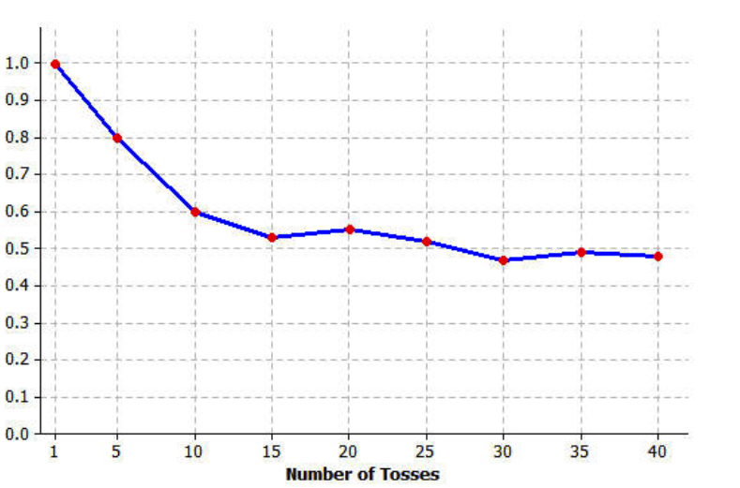

________________________________________________________________________________________________________________________________________________________________________________________________________________________________________________________________________________________________________________________________________________________________________________________________________________________________

- A spinner with four colors (red, blue, yellow, and green) is used for a probability experiment. The observed relative frequencies for the colors were recorded after 50 trials and again after 500 trials. Which table’s results would you expect to see? Explain
Table A: Table B:
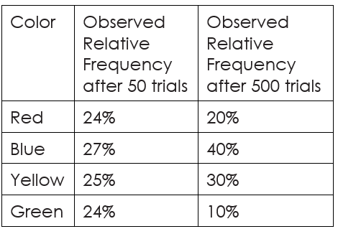
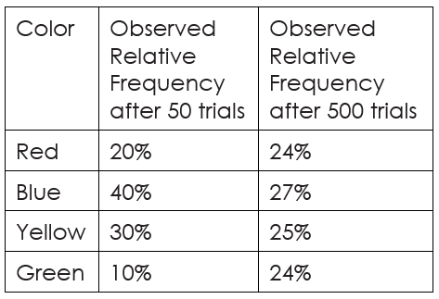

________________________________________________________________________________________________________________________________________________________________________________________________________________________________________________________________________________________________________________________________________________________________________________________________________________________________
INDEPENDENT PRACTICE

Bachelor Level

- Amanda used a standard deck of 52 cards and selected a card at random. She recorded the suit of the card she picked, and then replaced the card. The results are in the table below.
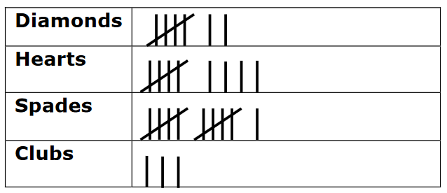

Step A: Based on her results, what is the observed relative frequency of selecting a heart?

Step B: What is the theoretical probability of selecting a heart?

Step C: Explain the difference in the two quantities. Were enough trials conducted? If yes, explain why. If not, propose a number of trials that should be conducted.

________________________________________________________________________________________________________________________________________________________________________________________________________________________________________________________________________________________________________________________________________________________________________________________________________________________________________________________________________________________________________________________________________________________________________________________________________________________________________________

Master Level

- Rolling a six-sided dice is a common tool used in chance games.

Step A: Determine the theoretical probability of landing on a selected number and represent it as a percent to the nearest tenth of a percent.

Step B: Use the online spinner to model rolling a six-sided dice by creating a spinner with six equal spaces and assigning a color to the numbers 1-6 (like you would see on the dice). Record your results in the table provided below corresponding to the correct number of trials.

Color | Number | 10 Trials | 25 Trials | 50 Trials | 100 Trials | 200 Trials | 500 Trials
 | 1
 | 2
 | 3
 | 4
 | 5
 | 6

Step C: Use your results to make a prediction what the probabilities will be for each after 1000 trials.

Step D: Use the spinner to conduct 1000 trials and compare your prediction to the actual observed relative frequencies. Explain if our original conjecture continues to hold true.

________________________________________________________________________________________________________________________________________________________________________________________________________________________________________________________________________________________________________________________________________________________________________________________
PhD Level

- The numbers 1 – 8 are put into a hat.

Step A: Explain how you could use an online spinner to conduct a probability experiment to simulate pulling out a number and replacing it 100 times.

________________________________________________________________________________________________________________________________________________________________________________________________________________________________________________________________________________________________________________________________________________________________________________________

Step B: Explain how you could use the results of the simulation to determine the number of times you could expect to pull the number 3 out of the bag if you conducted 1000 trials.

________________________________________________________________________________________________________________________________________________________________________________________________________________________________________________________________________________________________________________________________________________________________________________________

Step C: Explain how you could use theoretical probability to determine the answer to Step B.

________________________________________________________________________________________________________________________________________________________________________________________________________________________________________________________________________________________________________________________________________________________________________________________

Step D: Make your predictions and use the online probability simulator to conduct your experiment to verify your results
Name: ______________________________ Date: _______________________
EXIT TICKET
Self-assessment | I mastered the learning objective today. | I am almost there. | Need more practice and feedback.
Teacher feedback | You mastered the learning objective today. | You are almost there. | You need more practice and feedback.

      - Brandon wants to create a probability experiment with a coin toss. He plans to conduct eight trials in his experiment. He predicts that half of the trials will result in tails.
- Is his prediction an example of relative frequency or theoretical probability and why?

________________________________________________________________________________________________________________________________________________________________________________________________________
- Which of the two graphs could not be a graph that represents the results of the 8 trials? Why?
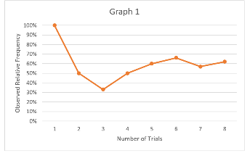
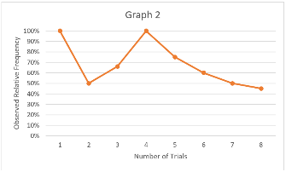
__________________________________________________________________________________________________________________________________________________________________________________________________________________________________________________________________________________________________________________________________________________________________________________________________________________________________________________________________________________________________________________________________________________________________________________________________________________________________________________________________________________________________________________________________________________________________________________________________________________________________________________________________________________________________________________________________________________________________________________________________________________________________________________

2. After Brandon finishes the experiment, he decides to perform a second experiment with 20 trials, and a third experiment with 200 trials. Below are two different scenarios for the results of both experiments. Which answer choice best explains which scenario could represent the results of his additional experiment?

a) Both scenarios because all of the values are the same.
b) Scenario 1 because the fewer trials you complete, the closer the observed relative frequency is to the theoretical probability
c) Scenario 2 because the more trials you complete, the closer the observed relative frequency is to the theoretical probability
d) Neither scenario because the observed relative frequencies do not match the theoretical probabilities

