Name: ___________________________ Date: ____________________________
UNIT 7 LESSON 6

AIM: SWBAT predict the outcomes of chance experiments

THINK ABOUT IT!
Marcy is going to conduct a probability experiment of tossing a coin and seeing how many times it lands on heads. Predict how many times Marcy can expect the coin to land on heads if she conducts 10, 50, or 192 trials.

  - 10 trials

  - 50 trials

  - 192 trials

Explain how you determined your answer.

________________________________________________________________________________________________________________________________________________________________________________________________________________________________________________________________________________________________________________________________________________________________________________________________________

Key Point:

Interaction with New Material
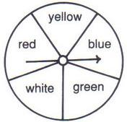
Ex.1) Brianna is using the spinner below to conduct probability experiments. Which of the following statements would you expect to be true (select all that apply)

- If the spinner is spun 100 times, it will land on yellow about 20 times

- If the spinner is spun 48 times, it will land on green exactly 9.6 times

- The spinner will land on yellow, blue, or white exactly $199\frac{4}{5}$ times if spun 333 times.

- The spinner will not land on red or yellow about 200 times if spun 333 times

PARTNER PRACTICE

Bachelor Level

- Jose is rolling a 6 sided dice.

- If he rolls the dice 60 times, how many times do you predict it will land on 5?

- If he rolls the dice 120 times, how many times do you predict it will land on a multiple of 3?

- If he rolls the dice 100 times, how many times do you predict it will land on an even number?

- If he rolls the dice 100 times, how many times do you predict it will land on 6?

Master Level

- In the spinner below, green, yellow, and red are all ¼ of the spinner. Blue and white are both equal in size.
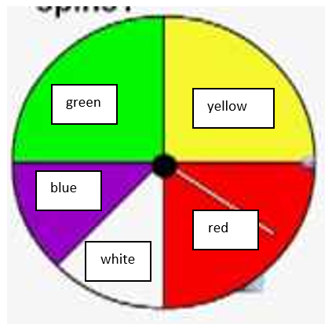
  - Predict the number of times the spinner will land on white if spun 150 times.

  - Predict the number of times the spinner will not land on yellow, red, or blue if spun 200 times.

- In Saradine’s bag of marbles, 25% are purple, 10% are yellow, 50% are blue, and 15% are white. If she randomly selects a marble from the bag 30 times, how many times do you expect her to pull a yellow marble?

INDEPENDENT PRACTICE

Bachelor Level

- Jared spins the spinner below in several different experiments.

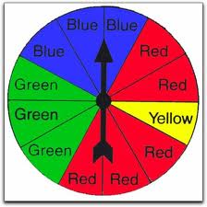
  - First, he does 100 trials. How many times do you predict he’ll land on red or yellow?

  - Next, he conducts 36 trials. Predict how many times he lands on green.

- Kayla randomly pulls one marble out of the bag below.
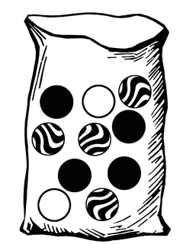
  - If Kayla conducts 150 trials, how many times do you expect her to select each marble?

  - If Kayla conducts 25 trials, how many times do you expect her to pull a white or black marble?

Master Level

- Rebekah flips a coin 25 times. Which is the best prediction for the outcome? Explain

  - The coin will land on heads 20 times and tails 5 times.
  - The coin will land on heads 12 or 13 times and tails 12 or 13 times.
  - The coin will land on heads 12.5 times and tails 12.5 times.
  - The coin will land on heads 10 times and tails 15 times.

____________________________________________________________________________________________________________________________________________________________________________________________________________________________________________________________________________________________________________________________________________________________

- Jared is spinner the same spinner (as in question 1). If he conducts a third experiment with 50 trials, predict how many more times he’ll land on red than yellow.

- Ricardo says that if he rolls a six-sided die 60 times, he is guaranteed to roll a 6 exactly ten times. His supporting work is shown below.

$\frac{successes}{total outcomes } → \frac{1}{6}=\frac{x}{60}$

- x 10 = 10; 1 x 10 = 10

Do you agree with Ricardo? Why or why not? Explain.

____________________________________________________________________________________________________________________________________________________________________________________________________________________________________________________________________________________________________________________________________________________________

- Yasmine has a bag of snacks that contains 40% Cheetos, 25% Doritos, 10% Fritos, and 25% pretzels.

  - If she reaches into the bag and grabs one snack, and does so 15 times, how many Cheetos do you expect her to get?

  - Yasmine likes all the types of snacks except for Doritos. If she grabs a total of 40 snacks, about how many times will she get a type of snack that she likes?

PhD Level

- Use the spinner below to answer the following questions. (Hint: the orange and green sectors are equivalent in size; the red and yellow are equivalent in size; and the larger sectors are exactly twice the size of the smaller sectors.)

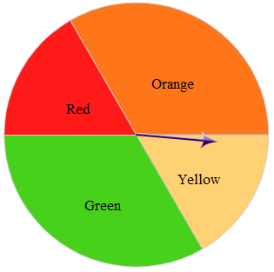

- If Marianne spins the spinner 600 times, how many times do you predict the spinner will land on orange?

- If Alex spins the 300 times, predict how many more times it will land on yellow than green.

- If Pedro spins the spinner 450 times, how many times will it land on orange or green?

- Is this spinner an example of uniform or non-uniform probability? How do you know?

____________________________________________________________________________________________________________________________________________________________________________________________________________________________________________________________
Name: ______________________________ Date: _______________________
EXIT TICKET
Self-assessment | I mastered the learning objective today. | I am almost there. | Need more practice and feedback.
Teacher feedback | You mastered the learning objective today. | You are almost there. | You need more practice and feedback.

- If Ms. Coronia rolls a six-sided die 40 times, which statement is most accurate about the predicted results?

  - She is likely to land on 4 exactly $6\frac{2}{3}$ times
  - She is likely to land on 1, 2, 3, or 4 exactly $26.\overline{6}$ times
  - She is likely to land on 3 or 5 about 14 times
  - She is likely to land on 1, 2, or 3 about 30% of the time

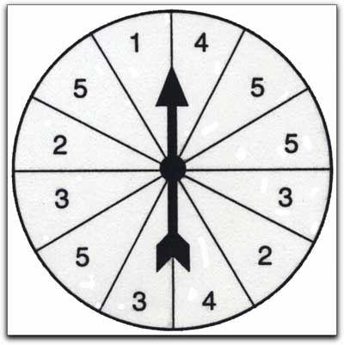
- Two students are conducting probability experiments with the same spinner. Student A spins the spinner 100 times trying to land on 5’s and 2’s. Student B spins the spinner 300 times trying to land on 1’s. Jayla thinks that Student B will have more success because s/he has conducted more trials. Do you agree or disagree with her claim? Explain your reasoning.

__________________________________________________________________________________________________________________________________________________________________________________________________________________________________________________________________________________________________

