Name: ___________________________ Date: ____________________________
UNIT 7 LESSON 8

AIM: SWBAT predict the future events from experimental results

THINK ABOUT IT!
Mr. Bauling conducts a probability experiment where he randomly picks a marble out of a bag without looking, records the color, and then puts the marble back. The table below shows the results after 10 trials.

Marble Type | Frequency
Clear | 1
Black | 5
Stripped | 4

If Mr. Bauling conducted the experiment 200 more times, how many times could he expect to pull out a stripped marble?

Key Point:

Interaction with New Material
Ex.1) Mr. Hawke and Mr. Horton are trying to figure out how many scholars at Elm City College Prep like chocolate ice-cream vs. vanilla. During morning arrival, Mr. Hawke asks the first 10 scholars that walk through the door which ice-cream they prefer and 7 respond that they like chocolate best. Mr. Horton asks 40 scholars during morning book club and 25 say they like chocolate best.

Step A: If they asked every scholar in ECCP which ice-cream they prefer, how many scholars would Mr. Hawke and Mr. Horton expect to say they prefer chocolate if there are 240 scholars that attend ECCP?

Step B: Whose prediction do you believe is more accurate? Why?

____________________________________________________________________________________________________________________________________________________________________________________________________________________________________________________________________________________________________________________________________________________________________________________________________________________________________________________________________________________________________________________________________________________________________________________________________________
PARTNER PRACTICE

Bachelor Level

- Mark rolled one die 50 times, and his results are shown below.

Outcome | Frequency
1 | 7
2 | 9
3 | 10
4 | 3
5 | 8
6 | 13

If Mark rolls the pair of dice 400 times, predict the number of times the dice will land on six.

- Deshawn surveyed 40 random scholars in his school and found that 34 of them have at least one sibling. There are 160 scholars at the school in total. Based on the data Deshawn already collected, predict the total number of scholars in the school who will have at least one sibling.

Master Level

- 90 contestants competed on a game show. The summary of their winnings is shown in the table below.
Winnings | Number of Contestants
$0-$2,000 | 18
$2,001-$4,000 | 22
$4,001-$6,000 | 17
$6,001-$8,000 | 25
$8,001-$10,000 | 8

Part A: If a total of 200 contestants play on the game show this year, how many, in total, do you predict will earn over $8,000? Base your answer on the results shown above.

Part B: Based on these results, what is the probability as a percent that the next contestant will win over $6,000?

Part C: What would improve the accuracy of this prediction?

____________________________________________________________________________________________________________________________________________________________________________________________________________________________________________________________
INDEPENDENT PRACTICE

Bachelor Level

The table below shows how much money a random sampling of parents in New York donated to charity last month.

Money Donated to Charity
Amount of Money | Number of New Yorkers
Under $20 | 11
$21 - $40 | 22
$41 - $60 | 37
$61 - $80 | 18
$81 and up | 12

- If there are 600 parents at AFCHMS, predict how many will donate between $21 and $40 next month.

- Out of the 1,150 parents in our AF Crown Heights community (middle and elementary school students), how many do you predict will donate at least $41 in the next month?

Master Level

- Savannah has a box full of pens of all different colors. She randomly pulled a pen from the bag 15 times, recorded the color, and replaced the pen. The results of her experiment are shown below.

Blue | Black | Red
6 | 5 | 4

If she conducts 60 trials of this experiment, how many times do you think she’ll pick a red pen?

- Tishanna is experimenting with the same bag of pens. She randomly pulls a pen out of the bag 30 times, records the color, and replaces the pen. Her results are shown below.
Blue | Black | Red
13 | 9 | 9

Step A: Now make a prediction for how many times Tishannah would pick a red pen, if she conducted 60 trials of the experiment.

Step B: Which prediction are you more confident in – the prediction in question # 3, or the prediction you made in question # 4? Why? Explain.

____________________________________________________________________________________________________________________________________________________________________________________________________________________________________________________________

Step C: If she conducts 60 trials of this experiment, how many more times do you think she’ll pick a blue pen than a black pen?

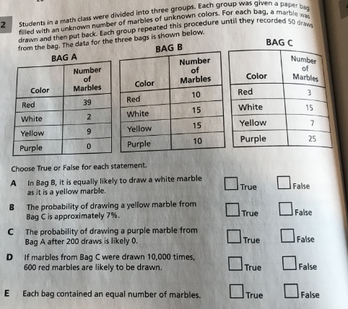

PhD Level

- The graph represents the results of one seventh grade class in the school. Use the data to make predictions about the scholars in the entire middle school (300 students).

If you were planning an ice cream social for all 300 students in the school, how much of each flavor would you order? (You can order per person; for example, “Vanilla for 100 people.”

Name: ______________________________ Date: _______________________
EXIT TICKET
Self-assessment | I mastered the learning objective today. | I am almost there. | Need more practice and feedback.
Teacher feedback | You mastered the learning objective today. | You are almost there. | You need more practice and feedback.

- John did an experiment pulling marbles out of a bag, without knowing the contents of the bag. After performing 20 trials, John had pulled 3 red marbles, 11 blue marbles, and 6 orange marbles. He knows that there are 10 marbles in the bag. How many orange marbles could he expect to pull if he performed a new trial with a total of 1,000 trials?

a) 3
b) 6
c) 300
d) 600

- John did a second experiment in which he pulled a marble out of a bag 100 times. His results are shown in the table below.
Red | Blue | Orange | White
12 | 41 | 41 | 6
Based on these results, how many orange marbles could he expect to pull if he performed a total of 1,000 trials?

- Which prediction are you more confident in – your prediction for question #1, or question # 2? Why? Explain.

______________________________________________________________________________________________________________________________________________________________________________________________________________________________________________________________________________________________________________________________________________________________________________________________________________________________________________________________________________________

