Name: ___________________________ Date: ____________________________
UNIT 7 LESSON 9

AIM: SWBAT determine the sample space and total number of outcomes of a compound event

THINK ABOUT IT!
The diagram below is a tree diagram that is used to determine all the outcomes (sample space) of flipping a coin followed by spinning the spinner shown.

Coin = 2 outcomes (heads and tails) Spinner = 3 Outcomes (white, red, and blue)
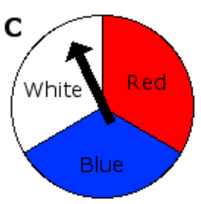
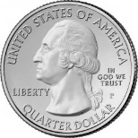

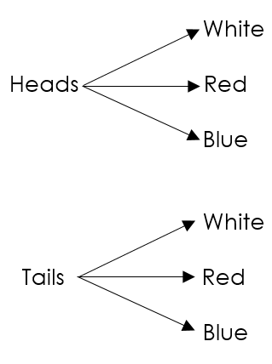

Outcomes (Sample Space)
Heads and White
Heads and Red
Heads and Blue
Tails and White
Tails and Red
Tails and Blue

Total Outcomes = 6

Create your own tree diagram that shows the sample space of rolling a six-sided number cube and flipping a coin.

Coin = _____ Outcomes Dice = _____ Outcomes
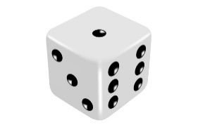

Test the Conjecture #1) What are the total number of outcomes of flipping a coin twice and spinning the spinner?

Test the Conjecture #2) A sandwich shop offers different styles of bread, meat, cheese, and condiment listed in the table below. How many different types of sandwich could be made if someone ordered one of each column?

Bread | Meat | Cheese | Condiment
White  Wheat  Rye | Turkey  Ham  Chicken  Roast Beef | American  Swiss | Mayo  Mustard

Conjecture
PARTNER PRACTICE

Bachelor Level

- Sarah spins a spinner with equal sections labeled A, B, C, and rolls a six-sided die. What is the total number of outcomes in her experiment? Prove your answer using a tree diagram.
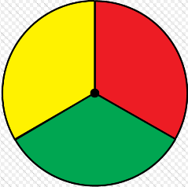
B
A

C

- Ms. Glass is going to choose a scholar to help her write the aim on the board (either a girl or a boy), and she’s then going to choose the color marker the scholar will use (either purple, green, light blue, or red). Create a tree diagram to help you list the sample space for this situation.

Master Level

- Cynthia is thinking of a two-digit number. Use the fundamental counting principal to prove the total number of two-digit numbers she could pick from. Explain why your answer makes sense.

___________________________________________________________________________________________________________________________________________________________________________________________________________________________________________________________________________________________________________________________________________________________________________________________________________________________________________________
INDEPENDENT PRACTICE

Bachelor Level

- Alice spun a spinner with 3 sections (Red, Yellow, Blue), then flipped a coin, then rolled a six sided dice.
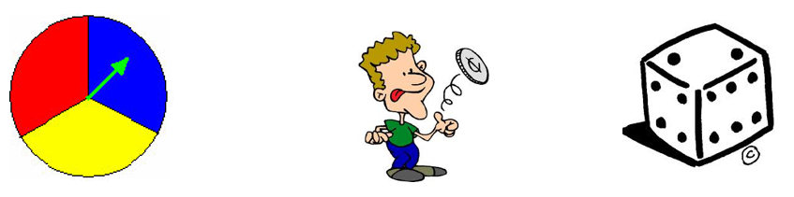

Step A: Determine the number of possible outcomes for each of the three events.

Step B: What is the total number of possible outcomes?

Step C: Prove your answer is correct by drawing a tree diagram

- Fred is taking a summer program at NYU and he attends classes for 3 periods each day. He gets to choose one class to take during each period, and his options are shown below. How many combinations of classes does he have to choose from?

Period 1 | Period 2 | Period 3
- The History of Film-Making  - The Adolescent Novel  - What You Never Knew about the US Presidents  - Geography and Travel | - The Psychology of a Teenager  - Writing the Novella  - TV Production | - Poetry Loves Club  - Baseball in World War II  - Beginning Chinese  - Beginning Arabic  - Beginning Japanese  - Beginning Spanish  - Beginning French  - Beginning Swahili

Master Level

- Javier is going to toss 5 pennies. How many total outcomes are there for this experiment? Confirm your answer with a tree diagram.

- Margo goes to the Salad Shack and can pick one item from each category to create her own salad. Margo looks at the menu and exclaims “There are thousands of options!”. Do you agree with Margo? Explain.

Greens | Protein | Veggies | Extras | Dressings
Romaine  Spinach  Mixed greens  Arugula | Chicken  Shrimp  Salmon  Steak  Tofu | Carrots  Celery  Peppers  Onions  Mushrooms  Artichoke  Asparagus  Avocado | Parmesan cheese  Blue cheese  Chopped egg  Bacon bits | Balsamic vinaigrette  Ranch  Blue cheese  Thousand island  Russian  Raspberry vinaigrette

____________________________________________________________________________________________________________________________________________________________________________________________________________________________________________________________________________________________________________________________________________________________
- A while back, Mr. Tejada made a friendly bet with Lilliana that he could “crack the code” on her iPhone. Her code is 4 digits long and only uses numbers. How many different codes would Mr. Tejada have to try to be certain that he named the correct one?

PhD Level

- Michael is trying to guess Marcelis’ passcode, which contains 4 vowels. What are the chances that he gets the code right on his first try?

- Marcelis is trying to guess Michael’s passcode, which contains 4 consonants. What are the chances that Marcelis guesses Michael’s code on the first try?

- Whose passcode is less likely to be broken into – Michael’s, or Marcelis’? Explain your answer.

___________________________________________________________________________________________________________________________________________________________________________________________________________________________________________________________________________________________________________________________________________________________________________________________________________________________________________________
Name: ______________________________ Date: _______________________
EXIT TICKET
Self-assessment | I mastered the learning objective today. | I am almost there. | Need more practice and feedback.
Teacher feedback | You mastered the learning objective today. | You are almost there. | You need more practice and feedback.

- Javier is going to toss 3 pennies. Use a tree diagram to determine the sample space of the probability experiment.

2. Tiyana is making an ice cream sundae, using the options below. Her mom says she’s allowed to pick one item from each category listed on the menu. How many different combinations does she have to choose from? Explain.

Ice Cream Flavors | Cold Toppings | Hot Toppings | Syrup
Chocolate  Vanilla  Coffee  Cookie dough  Mint chocolate chip  Coffee | Snickers  Sprinkles  Butterfinger  Blueberries  Strawberries  Reeses  M & Ms  Raspberries | Hot fudge  Hot caramel sauce | Peanut Butter  Honey  White Chocolate  Dark Chocolate  Strawberry

__________________________________________________________________________________________________________________________________________________________________________________________________________________________________________________________________________________________________________________________________________________________________________________________________________________________________________________________________________________________________________________________________________

