Name: ___________________________ Date: ____________________________

UNIT 9 LESSON 11

AIM: SWBAT solve real-world problems involving surface area and volume

**THINK ABOUT IT!**

Determine if each real-life example relates to finding the surface area (SA) or volume (V) of a figure. Label each example on the line.

1. The amount of sand necessary to fill a sandbox 🡪 _____
2. Wrapping a rectangular box in yellow wrapping paper 🡪 _____
3. The quantity of water you can put into a tank 🡪 _____



1. Painting the outside of a box 🡪 _____
2. The cardboard necessary to wrap a Toblerone Bar in aluminum foil 🡪 _____
3. The amount of chocolate in a Toblerone 🡪 _____
4. 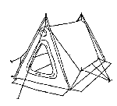How many supplies you can store in a 5 ft x 10 ft x 8 ft storage compartment 🡪 _____
5. The amount of cardboard necessary to create a cereal box 🡪 _____
6. The amount of nylon needed to create all sides of a tent 🡪 _____
7. The amount of space inside the tent 🡪 _____
8. The amount of trash that can fit inside a trash can 🡪 _____
9. The amount of water than can fit in a swimming pool 🡪 _____

Key Point

|  |
| --- |
|  |

**Interaction with New Material**

Ex. 1) An airfreight company uses a box in the shape of a triangular prism to pack blueprints, posters, and other items that can be rolled up to fit inside the box. Each base is an equilateral triangle. The dimensions of the box are shown below.

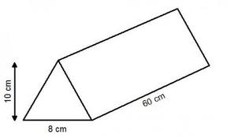

6 in

38 in

5 in

1. The freight company needs to first wrap the entire box in packing tap. How many square inches will be covered with tape?
2. How many cubic inches of material can be packed within the prism?

1. Another airfreight company uses a box shaped like a rectangular prism for the same purposes. The rectangular prism is also 38 inches long, and each of its square bases has a length of 3 inches. Which box takes up more space?

3 in

38 in

**PARTNER PRACTICE**

|  |
| --- |
| *Bachelor Level* |

1. As a treat, Louise fills and freezes orange juice in the tray shown. Each compartment of the tray is a rectangular prism with the dimensions 4cm by 3 cm by 3 cm. What is the total number of cubic centimeters for the entire tray?

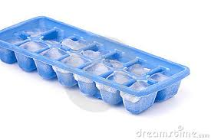

1. Explain which concept you used to solve the problem and how you knew to apply that concept.

___________________________________________________________________________________________________________________________________________________________________________________________________________________________________________________________________________________________________________________________________________________________________________________________________________________________________________________

|  |
| --- |
| *Master Level* |

1. A window box shaped like a rectangular prism has a length of 12 in., a width of 9 in., and a height of 9 in.
2. Find the total amount of space within the window box.



1. One bag contains 12 cubic inches of soil. How many bags of soil must you buy to fill the window box? You must buy full bags of soil.
2. Each bag of soil costs $1.97, including tax. Estimate the cost of filling the window box with soil.

**INDEPENDENT PRACTICE**

|  |
| --- |
| *Bachelor Level* |

1. How much paint is necessary to paint the entire surface?

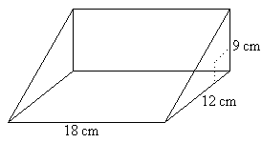

1. What concept did you apply to solve this problem? What about the problem helped you determine the concept?

____________________________________________________________________________________________________________________________________________________________________________________________________________________________________________________________________________________________________________________________________________________________________________________________________________________________________

|  |
| --- |
| *Master Level* |

1. The box below is a plain necklace case. Ashanti wants to decorate the entire outside of the box with little bedazzled jewels. Each jewel is only 4 square millimeters in area. How many packs of jewels will she need to buy if each package comes with 100 jewels?



6 mm

1. Lynette is painting a 15-foot by 10-foot rectangular wall that has a 9-foot by 5-foot-rectangular window at its center. How many square feet of wall will she paint?

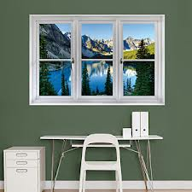

15 ft

10 ft

9 ft

5 ft

1. Jane is painting every surface of the shape below.

Part A: How many square inches will she cover with paint?



Part B: What is the volume of the shape?

|  |
| --- |
| *PhD Level* |

1. A rectangular prism has dimensions 3 inches, 4 inches, and 5 inches. Find the dimensions of another rectangular prism with the same volume **but less surface area.** Prove your answer is correct showing all calculations

**Name: ______________________________ Date: _______________________**

**EXIT TICKET**

|  |  |  |  |
| --- | --- | --- | --- |
| Self-assessment | I mastered the learning objective today. | I am almost there. | Need more practice and feedback. |
| Teacher feedback | You mastered the learning objective today. | You are almost there. | You need more practice and feedback. |

1. Efficient packaging uses the least amount of material for the greatest capacity. Which package is more efficient? Justify your answer.



