Name: ___________________________ Date: ____________________________

UNIT 9 LESSON 2

AIM: SWBAT determine area of composite figures

**THINK ABOUT IT!**

Determine the approximate area of the figure below.



12in

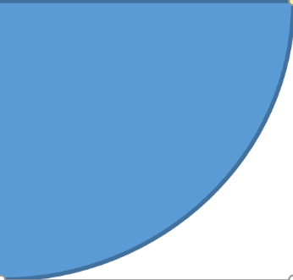

5in

5in

Key Point

|  |
| --- |
|  |

**Interaction with New Material**

Ex. 1) Al-Shacore was asked to paint part of his school’s basketball court shown below (not drawn to scale). The top portion of the shape has two right angles and the bottom portion is a semi-circle. He wants to first cover the floor with a base paint. How many square feet will he cover with the base paint? Find an exact answer.

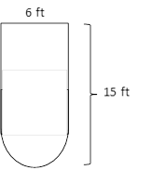

**PARTNER PRACTICE**

|  |
| --- |
| *Bachelor Level* |

1. Calculate the approximate area of the shaded region using 3.14 for pi for both circles.

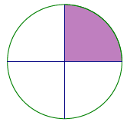

The diameter of the circle above is 10 inches.

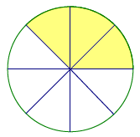

$$12 ft.$$

1. Determine the area of the figure below:

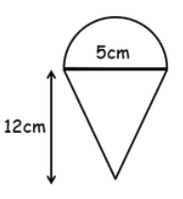

|  |
| --- |
| *Master Level* |

1. The square in the figure below has a side length of 14 inches. Each quarter circle is congruent. Find the area of the shaded portion of the figure below. Use 3.14 for pi.



1. The diameter of the circle is $12 in.$ Write two different numerical expression that represents the area of the shaded region.

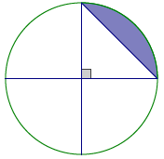

Expression 1: ___________________ Expression 2: ______________________

**INDEPENDENT PRACTICE**

|  |
| --- |
| *Bachelor Level* |

1. Calculate the areas of the follwing figures:
2. 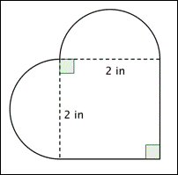
3. 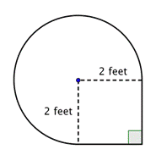

|  |
| --- |
| *Master Level* |

1. Determine the area of the shaded figure:

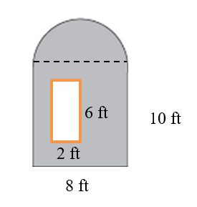

1. The vertices A and B of rectangle ABCD are centers of circles each with a radius of 5 inches. Determine the area of the shaded region.

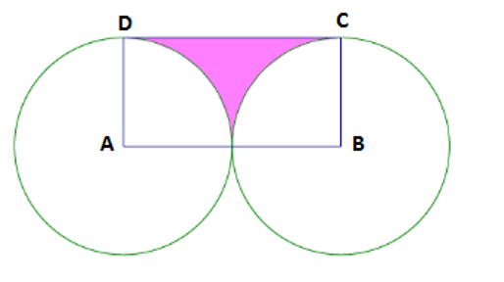

1. Ten dartboard targets are being painted as shown in the following figure. The radius of the smallest circle is $3 in.$, and each successive larger circle is $3 in.$ more in radius than the circle before it. A can of red paint and a can of white paint is purchased to paint the target. Each $8 oz.$ can of paint covers $16 ft^{2}$. Is there enough paint of each color to create all ten targets?

|  |
| --- |
| *PhD Level* |

1. The Smith family is renovating a few aspects of their home. The following diagram is of a new kitchen countertop. Approximately how many square feet of counter space is there?

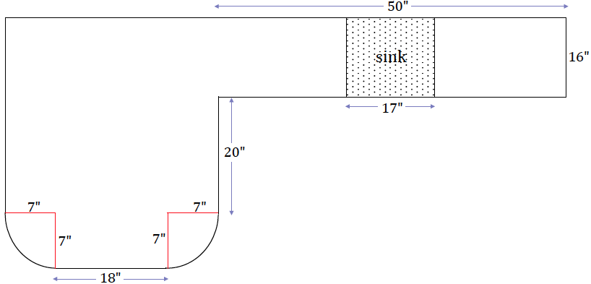

**Name: ______________________________ Date: _______________________**

**EXIT TICKET**

|  |  |  |  |
| --- | --- | --- | --- |
| Self-assessment | I mastered the learning objective today. | I am almost there. | Need more practice and feedback. |
| Teacher feedback | You mastered the learning objective today. | You are almost there. | You need more practice and feedback. |

1. Calculate the area of the figure below that is comprised of a rectangle and two identical quarter circles with the same radius. Approximate your answer using 3.14 for Pi.

