Name: ___________________________ Date: ____________________________

UNIT 9 LESSON 3

AIM: SWBAT calculate the surface area of rectangular prisms

**THINK ABOUT IT!**

Use the rectangular prism below to answer the following questions:

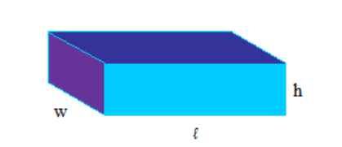

Step A: Label the areas of the three faces showing on the rectangular prism

Step B: How many of each face are there on the prism? Explain.

______________________________________________________________________________________________________________________________________________________________________________________________________________________________________________________________________________________________________

Step C: How could you algebraically represent the surface area of a rectangular prism?

Test the Conjecture #1) Determine the surface area of the rectangular prism

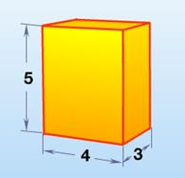

Test the Conjecture #2) Tori has a small jewelry box that she wants to cover in gold foil. How many square centimeters of gold foil will she need?

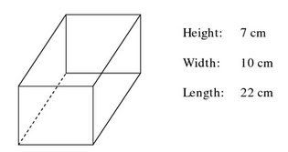

Conjecture

|  |
| --- |
|  |

**PARTNER PRACTICE**

|  |
| --- |
| *Bachelor Level* |

1. Determine the surface area of the figure below.

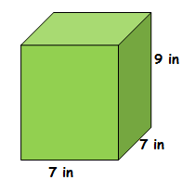

1. Use the formula to find the surface area of the rectangular prism that is 10.5 cm tall, 8 cm wide, and 20.2 cm long.

|  |
| --- |
| *Master Level* |

1. Mary has had the same jewelry box since she was 6 years old. It badly needs a paint job! Find the total surface area of the box so that Mary can color her entire jewelry box bright pink and make it look brand new. Round your answer to the nearest square inch.

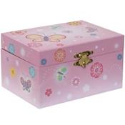

3.1 inches

4.2 inches

7.5 inches

4. Justin uses the expression SA = 7.5 x 3.1 + 7.5 x 4.2 + 3.1 x 4.2 to find the surface area of Mary’s jewelry box. What mistake did Justin make?

____________________________________________________________________________________________________________________________________________________________________________________________________________________________________________________________________________________________________________________________________________________________

**INDEPENDENT PRACTICE**

|  |
| --- |
| *Bachelor Level* |

1. Find the area of each surface of the figure. Organize your work!

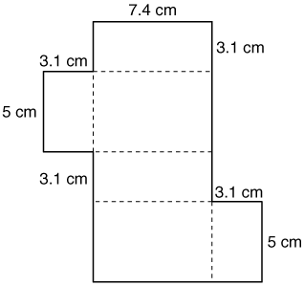

1. What is the total surface area of the figure?
2. Why can you also use the formula 2lw + 2wh + 2lh to find the surface area of the figure?

____________________________________________________________________________________________________________________________________________________________________________________________________________________________________________________________________________________________________________________________________________________________

|  |
| --- |
| *Master Level* |

1. **Part A:** Douggie is repainting his pantry, shown at the right. He wants to cover all the surfaces with blue paint. How many square meters of paint will he need?

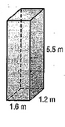

**Part B:** The blue paint costs $0.40 per square meter. How much will the paint job cost (round your answer to the nearest cent)?

**Part C**: Douggie realizes that he does not need to paint the back of the pantry or the bottom, since neither side will be visible. Given this adjustment, how much will the paint job cost now?

|  |
| --- |
| *PhD Level* |

1. Find the surface area of a cube with edge lengths of 3 centimeters.
2. How many of the cube’s faces were congruent to one another? How did this affect your process in finding the surface area?

____________________________________________________________________________________________________________________________________________________________________________________________________________________________________________________________________________________________________________________________________________________________

1. Write a formula to find the surface area of any cube.

_______________________________

1. A cube has a surface area of 96 square centimeters. What are the dimensions of the cube?

?

**Name: ______________________________ Date: _______________________**

**EXIT TICKET**

|  |  |  |  |
| --- | --- | --- | --- |
| Self-assessment | I mastered the learning objective today. | I am almost there. | Need more practice and feedback. |
| Teacher feedback | You mastered the learning objective today. | You are almost there. | You need more practice and feedback. |

1. Why does the formula SA = 2lw + 2lh + 2wh work for measuring the surface are of a rectangular prism?

__________________________________________________________________________________________________________________________________________________________________________________________________________________________________________________________________________________________________________________________________________________________________________________________________________________________________________________________________________________________________________________________________________

1. Jasmine wants to paint every surface of 5 boxes shaped like the box below. What is the total amount of square centimeters of paint that she’ll need?

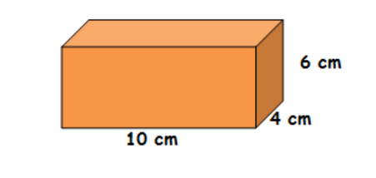

a) 240 sq. cm

b) 248 sq. cm

c) 620 sq. cm

d) 1,240 sq. cm