Name: ___________________________ Date: ____________________________
UNIT 9 LESSON 5

AIM: SWBAT determine the surface area of solids

THINK ABOUT IT!
Find the surface area of the solid below. Explain how you determined your answer.
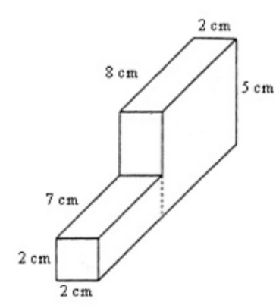

__________________________________________________________________________________________________________________________________________________________________________________________________________________________________________________________________________________________________________________________________________________________________________________________________________________________________________________________________________________________________________

Key Point

Interaction with New Material
Ex. 1) A cube-shaped hole is cut in a rectangular prism as shown below.

If x = 4 cm, y = 30 cm, and z = 24 cm, how much paint would you need to cover the entire outside of the figure?

PARTNER PRACTICE

Bachelor Level

- The longer piece of wood has dimensions of 1 inch by 1 inch by 8 inches. The short piece of wood has dimensions of 1 inch by 1 inch by 4 inches. How many square inches of paint would be needed to cover all sides of this object?

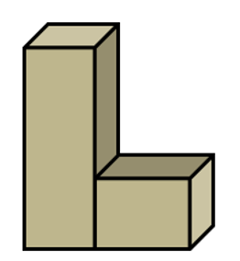
  - 52sqin.
  - 50sqin
  - 38sqin
  - 51sqin

Master Level

- A triangular prism is attached to a rectangular prism as shown below.

If w = 8 inches, x = 5 inches, y = 20 inches, and z = 11.3 inches, what is the surface area of the figure?
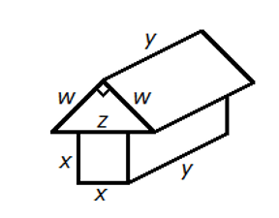
  - 960sqin
  - 1,060sqin
  - 760sqin
  - 860sqin

INDEPENDENT PRACTICE

Bachelor Level

- A cube with a square hole with $3 m$ side lengths has been cut through the cube. What is the total surface area?
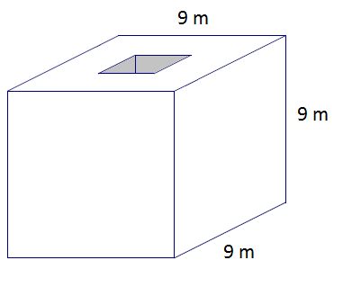

- Three same-sized cubes are attached to the top of a rectangular prism as shown below.

If a = 9cm, b = 24 cm, and c = 3cm, what is the surface area of the figure?

Master Level

For problems 3 and 4, determine the total surface area of the figure.

- The figure below has two square holes cut completely through them. The squares are 2m by 2m each.
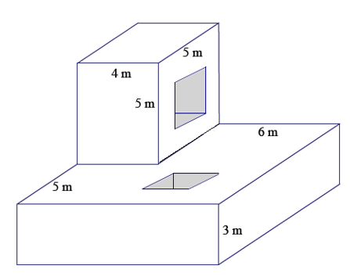

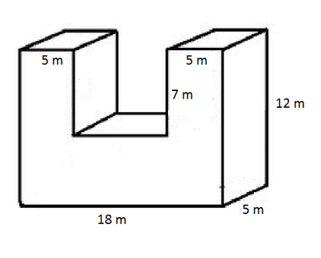

PhD Level

- Tyree is building the house shown below out of nylon. How many square feet of material will he need?

*Notes:
- Ignore the mattress at the bottom. Under the mattress, there is a layer of material.
- The back of the tent has a triangular window.
- The front of the tent is completely open.

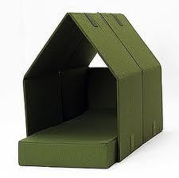
D = 5 feet
C = 3 feet
B = 2.5 feet
E = 4 feet
A = 2 feet

Tyree decides to add a sheet of material to cover the entire front side and create a door. How much material does he need now?

This special tent-material costs $5.25 per square foot. How much will Tyree need to pay to create the structure, door included?

Name: ______________________________ Date: _______________________
EXIT TICKET
Self-assessment | I mastered the learning objective today. | I am almost there. | Need more practice and feedback.
Teacher feedback | You mastered the learning objective today. | You are almost there. | You need more practice and feedback.

- Determine the surface area of the right rectangular prism after the two square prisms have been cut out.

