Name: ___________________________ Date: ____________________________

UNIT 9 LESSON 7

AIM: SWBAT determine the cross section of slices through a rectangular pyramid

**THINK ABOUT IT!**

The figures below are rectangular pyramids. Can you create three different shapes as a result of a slice parallel or perpendicular to the base? Draw the slice and label the corresponding cross-section.

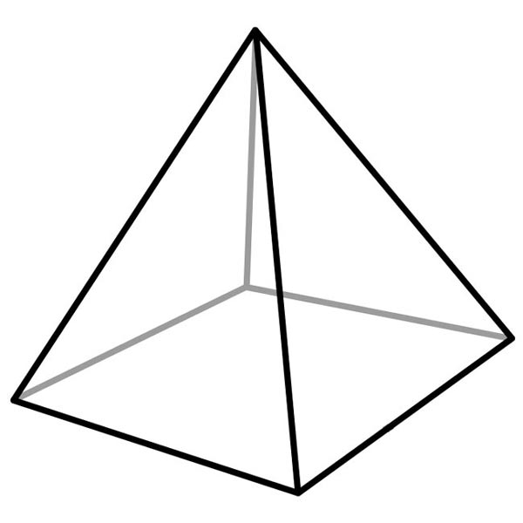





Key Point

|  |
| --- |
|  |

**Interaction with New Material**

Ex. 1) For the rectangular prism below, draw a perpendicular or parallel slice to the base to create the three different shapes from the Think About. Sketch the cross-section and label the cross-section with as many dimensions as possible.

Cross-Section 1: __________________________________

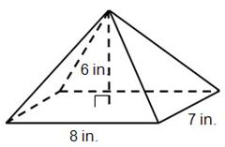

Cross-Section 2: __________________________________



Cross-Section 3: __________________________________



**PARTNER PRACTICE**

|  |
| --- |
| *Bachelor Level* |

1. Sketch a slice that would result in the cross-section being a rectangle. Sketch and label the cross-section.

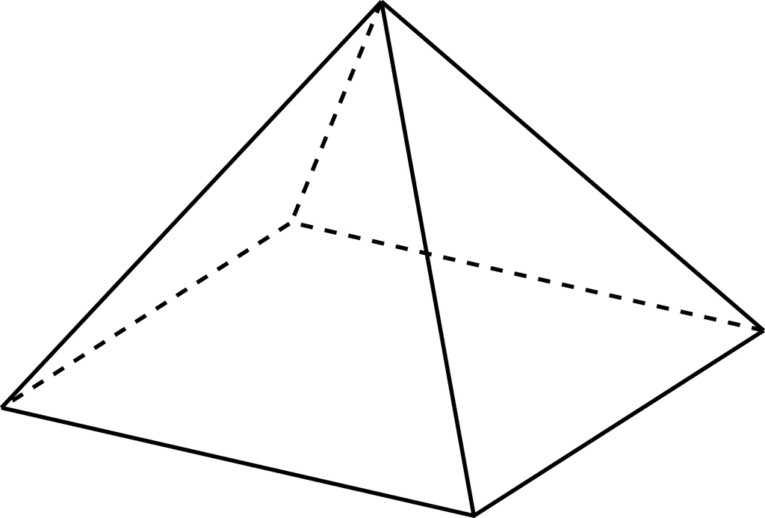

1. Explain why the area of the base of the solid in question 1 is not the same area as area of the cross-section you drew.

___________________________________________________________________________________________________________________________________________________________________________________________________________________________________________________________________________________________________________________________________________________________________________________________________________________________________________________

|  |
| --- |
| *Master Level* |

1. The rectangular pyramid is sliced parallel to its base. Sammy says that the resulting two-dimensional figure will be a triangle. Is Sammy correct? Why or why not?

[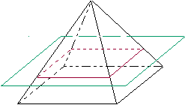](http://www.google.com/url?sa=i&rct=j&q=&esrc=s&frm=1&source=images&cd=&cad=rja&docid=E0k2QPS6ahW6pM&tbnid=IHvuNCe_x4cvdM:&ved=0CAUQjRw&url=http://intermath.coe.uga.edu/dictnary/descript.asp?termID=95&ei=D8u4UcmlEbLl0AH2oIHoBw&bvm=bv.47810305,d.dmQ&psig=AFQjCNE0gGaOsYTLnqhZUv_qV2qV-YA-zA&ust=1371151456291161)

____________________________________________________________________________________________________________________________________________________________________________________________________________________________________________________________________________________________________________________________________________________________________________

1. Determine the area of the cross-section formed from a perpendicular slice to the base through the apex. Could you and your partner have two different answers and both be correct? Explain.



___________________________________________________________________________________________________________________________________________________________________________________________________________________________________________________________________________________________________________________________________________________________________________________________________________________________________________________

**INDEPENDENT PRACTICE**

|  |
| --- |
| *Bachelor Level* |

1. A slice is to be made along segment $a$ perpendicular to base $B$ of the right rectangular pyramid below.
   1. Which of the following figures shows the correct slice? Justify why each of the following figures is or is not a correct diagram of the slice.



________________________________________________________________________________________________________________________________________________________________________________________________________________________________________________________

________________________________________________________________________________________________________________________________________________________________________________________________________________________________________________________

________________________________________________________________________________________________________________________________________________________________________________________________________________________________________________________

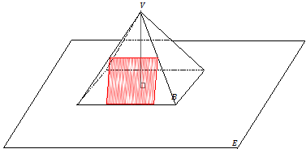

|  |
| --- |
| *Master Level* |

1. The figure below shows the beginning of a slice through the rectangular pyramid but it was never finished. Will wants to know if the cross-section will be a rectangle, trapezoid, or triangle. Does he have enough information to determine the shape of the cross-section? If no, what could the cross-section be? What could it definitely not be and why?



________________________________________________________________________________________________________________________________________________________________________________________________________________________________________________________________________________________________________________________________________________________________________________________________________________________________________________________________________________________________________________________________________________________________________________________________________________________________________________________________________________________________________________________________________________________

1. The figure below is a square pyramid. Which of the following is not a cross-section that can be formed as a result of a parallel or perpendicular slice? Explain your answer.

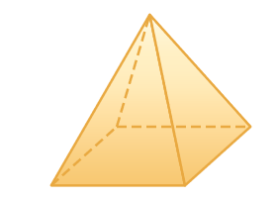

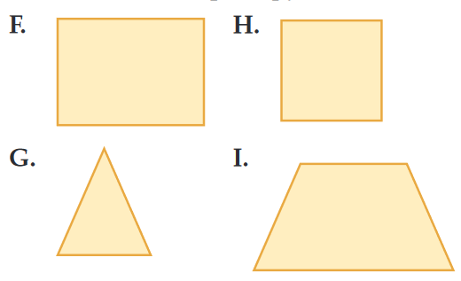________________________________________________________________________________________________________________________________________________________________________________________________________________________________________________________________________________________________________________________________________________________________________________________________________________________________________________________________________________________________________________________________________________________________________________________________________________________________________________

1. The cross-section of a rectangular pyramid cut parallel to the base creates a scaled figured of the base. If the base of a rectangular pyramid has a width of 20inches and a length of 15inches, how much larger is its area compared to a parallel slice resulting in a rectangle with a width of 4inches? Sketch where you think the slice would happen on the pyramid below and explain how you were able to determine your answer.



________________________________________________________________________________________________________________________________________________________________________________________________________________________________________________________________________________________________________________________________________________________________________________________________________________________________________________________________________________________________________________________________________________________________________________________________________________________________________________________________________________________________________________________

|  |
| --- |
| *PhD Level* |

1. A side view of a right rectangular pyramid is given. The line segments lie in the lateral faces.

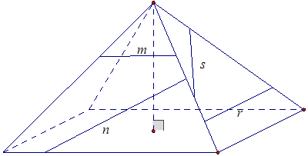

* 1. For segments $n$, $s$, and $r$, sketch the resulting slice from slicing the right rectangular pyramid with a slicing plane that contains the line segment and is perpendicular to the base.
  2. For segment $m$, sketch the resulting slice from slicing the right rectangular pyramid with a slicing plane that contains the segment and is parallel to the base.
  3. A top view of a right rectangular pyramid is given. The line segments lie in the base face. For each line segment, sketch the slice that results from slicing the right rectangular pyramid with a plane that contains the line segment and is perpendicular to the base.

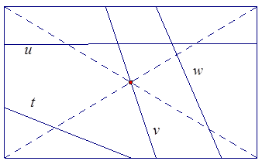

**Name: ______________________________ Date: _______________________**

**EXIT TICKET**

|  |  |  |  |
| --- | --- | --- | --- |
| Self-assessment | I mastered the learning objective today. | I am almost there. | Need more practice and feedback. |
| Teacher feedback | You mastered the learning objective today. | You are almost there. | You need more practice and feedback. |

1. Draw the cross- sectional areas that are formed from slicing the figure below in two ways:
   1. Parallel to its base
   2. Perpendicular to its base through the vertex.

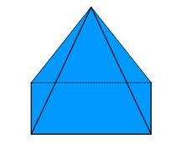

1. If you slice the figure perpendicular to the base through any other part of the solid than the vertex, will the resulting cross section be the same as that formed when creating a perpendicular slice through the vertex? Explain.

___________________________________________________________________________________________________________________________________________________________________________________________________________________________________________________________________________________________________________________________________________________________________________________________________________________________________________________