Name: ___________________________ Date: ____________________________
UNIT 9 LESSON 8

AIM: SWBAT determine the cross section of slices at angles

THINK ABOUT IT!
Go to the website http://www.learner.org/courses/learningmath/geometry/session9/part_c/ with your partner and fill in the following table shows the different shapes that can be made by slicing a cube at different angles. Record the shape and the number of faces that the slice intersects with.

Position | Number of Faces the Slice Intersects | Shape of the Cross-Section | Number of Sides of the Cross-Section
Position 1
Position 2
Position 3
Position 4
Position 5
Position 6
Position 7

What, if any, rule can you determine based on the results of the computer simulation?

________________________________________________________________________________________________________________________________________________________________________________________________________________________________________________________________________________________________________________________________________________________________________________________________________

Key Point

Interaction with New Material
Ex. 1) The figures below are a pentagonal pyramid and prism. Predict the maximum number of sides a cross-section of each figure can have as a result of a slice of the solid and then go to the website listed below, manipulate the figure to test that your prediction is correct, and use the visual to draw the slice on the figure. (Website: http://www.shodor.org/interactivate/activities/CrossSectionFlyer/)

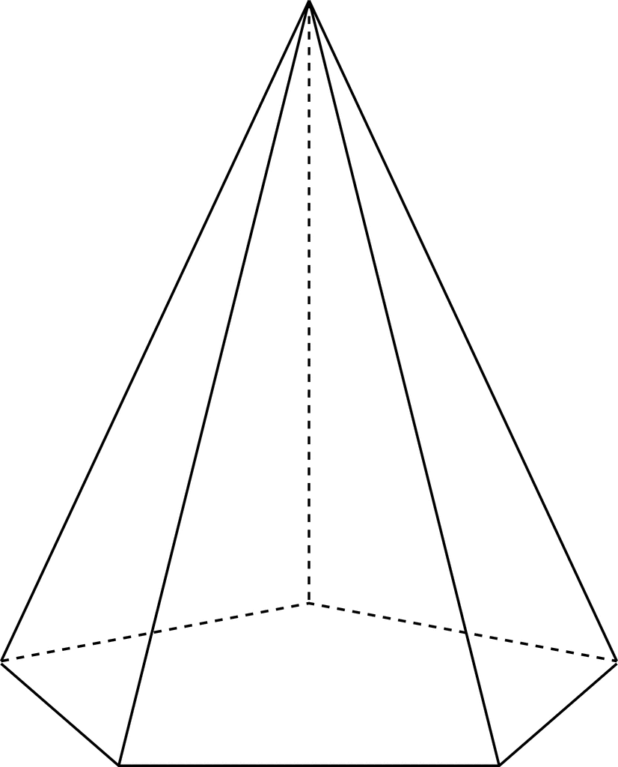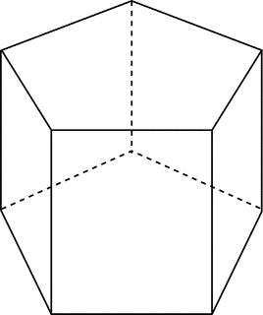

Ex. 2) A rectangular prism is cut in such a way that it intersects with the top face, the rectangular faces connecting the bases, and exits the prism at the bottom vertex without passing through the bottom base. What will be the shape of the cross-section?

PARTNER PRACTICE

Bachelor Level

- Can the right rectangular prism be sliced in such a way as to create a cross-section in the shape of figure 1? Explain and show the point of contact on the prism below.
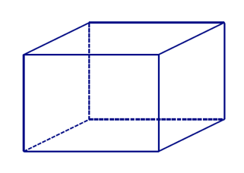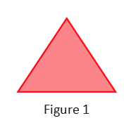

___________________________________________________________________________________________________________________________________________________________________________________________________________________________________________________________________________________________________________________________________________________________________________________________________________________________________________________

- Explain how you could modify the slice you made in question 1 so that the cross-section is in the shape of figure 2 instead. Show the points of contact on the solid.

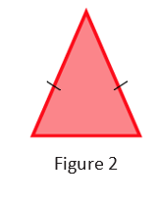

___________________________________________________________________________________________________________________________________________________________________________________________________________________________________________________________________________________________________________________________________________________________________________________________________________________________________________________
Master Level

- Which of the following shapes cannot be the result of a cross-section from slicing a cube? Explain

- Square
- Rectangle
- Triangle
- Octagon
- Pentagon

___________________________________________________________________________________________________________________________________________________________________________________________________________________________________________________________________________________________________________________________________________________________________________________________________________________________________________________

INDEPENDENT PRACTICE

Bachelor Level

- Can the solid below be sliced in such a way to produce a cross-section that looks like figure 1? Explain and show the points of intersection on the solid below if it can.
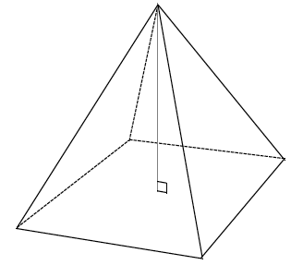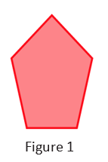

_____________________________________________________________________________________________________________________________________________________________________________________________________________________________________________________________________
Master Level

- Draw a slice into the right rectangular prism at an angle in the form of the provided shape, and draw each slice as a 2D shape.
 | Slice made in the prism | Slice as a 2D shape
- A triangle | 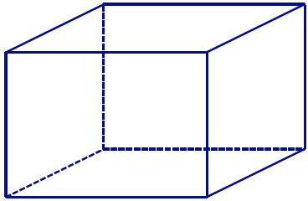
  - A quadrilateral
  - A hexagon
- Why is it not possible to draw a slice in the shape of a hexagon for a right rectangular pyramid?
__________________________________________________________________________________________________________________________________________________________________________________________________________________________________________________________________________________________
- Draw slices at an angle in the form of each given shape into each right rectangular pyramid, and draw each slice as a 2D shape.
 |  | Slice made in the pyramid | Slice as a 2D shape
 | - A quadrilateral
 | - A pentagon
PhD Level
- List all the different types of cross-sections that you could create from the following solids and explain how to create those shapes:
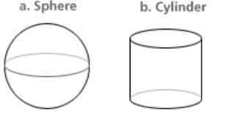
- Sphere:
________________________________________________________________________________________________________________________________________________________________________
- Cylinder
________________________________________________________________________________________________________________________________________________________________________

Name: ______________________________ Date: _______________________
EXIT TICKET
Self-assessment | I mastered the learning objective today. | I am almost there. | Need more practice and feedback.
Teacher feedback | You mastered the learning objective today. | You are almost there. | You need more practice and feedback.

- Name all the different shapes of cross-sections that can be created by slicing a rectangular pyramid and explain why these shapes can be created.
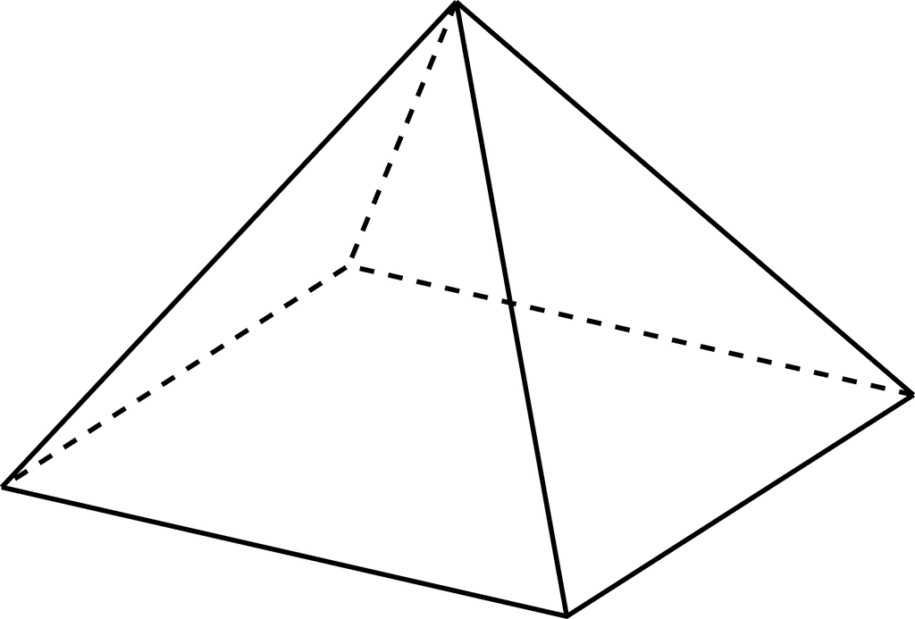

__________________________________________________________________________________________________________________________________________________________________________________________________________________________________________________________________________________________________________________________________________________________________________________________________________________________________________________________________________________________________________________________________________

- Mike says that cube below cannot be sliced in such a way as to create a triangular cross-section because the minimum number of sides the cross-section can have is four because each face is four-sided. Do you agree with Mike? Why or why not? Give an example that proves him right or wrong.




