Name: ___________________________ Date: ____________________________

UNIT 9 LESSON 9

AIM: SWBAT determine the volume of prisms

**THINK ABOUT IT!**

To find the volume of the rectangular prism below, Amy uses the formula for the volume of a rectangular prism V = l x w x h. Chris uses the formula V = B x h where B is the area of the base of the prism. Which scholar is correct? Prove your answer by using both formulas.

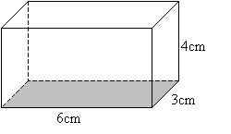

Key Point

|  |
| --- |
|  |

**Interaction with New Material**

Ex. 1) Determine the volume of the solid below.

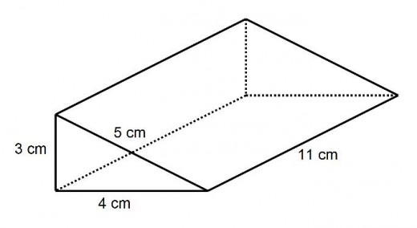

Ex. 2) A pentagonal prism has two congruent pentagons as the bases connected by five rectangular faces. The volume of the prism is 120 cubic inches and the height is 8 inches. What is the area of the pentagonal base?

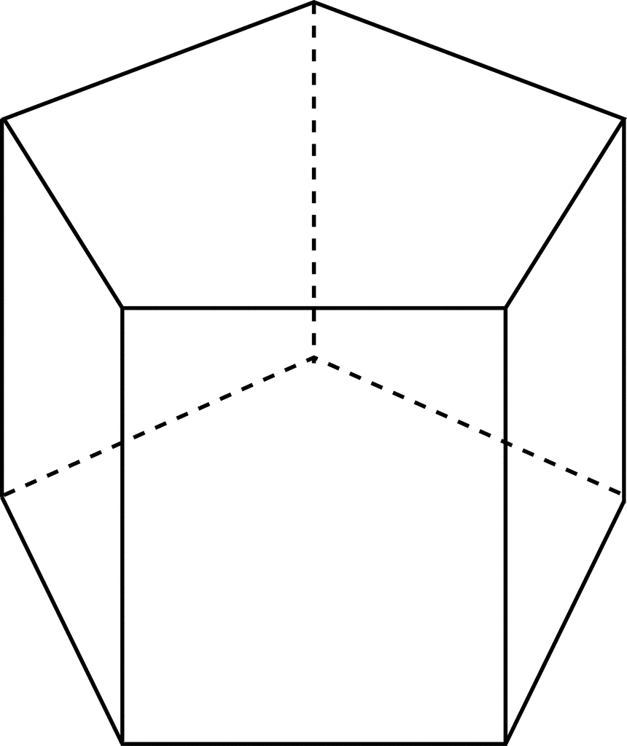

**PARTNER PRACTICE**

|  |
| --- |
| *Bachelor Level* |

1. If the area of the triangular face is 9.2 cm2, what is the volume of the triangular prism?



1. Why does the formula V = B x h work for finding the volume of a triangular prism?

________________________________________________________________________________________________________________________________________________________________________________________________________________________________________________________________________________________________________________________________________________________________________________________________________________________________

|  |
| --- |
| *Master Level* |

1. An aquarium is building a new tank for it’s largest shark. The dimensions of the tank are shown below. If the tank holds 480,000 cubic feet, how tall is the aquarium?

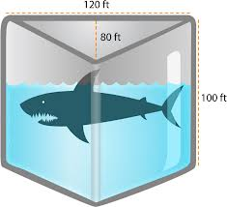

**INDEPENDENT PRACTICE**

|  |
| --- |
| *Bachelor Level* |

1. A rectangular prism has a width of 1.2in, a length of 2.4in and a height of 4in. What is the volume of this rectangular prism?

a.1.152 ${in}^{3}$

b. 11.52 ${in}^{3}$

c. 115.2 ${in}^{3}$

d. 1152in

1. What is the height of a rectangular prism with a base of 33in2 and a volume of 132in3?
2. 4356in
3. 44in
4. 12in
5. 4in

3. Find the volume of the triangular prism.

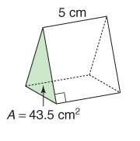

5 cm

8.7 cm

|  |
| --- |
| *Master Level* |

1. If the bases of the Toblerone bar below are equilateral triangles with a perimeter of 12 mm and a height of 3 mm, what is the volume of the candy bar if the length of the prism is 120 mm?
2. Lucy loves her swimming pool! The dimension of her pool are 5.2’ x 3.7’ x 6.4’ in the shape of a rectangular prism. Her friend, Paula did a huge cannonball in which 3.2 cubic feet of water were displaced. How much water is left in Lucy’s pool after Paula’s cannonball?
3. A large skateboard ramp is shown. What is the height of the ramp if the volume is 40cm3?

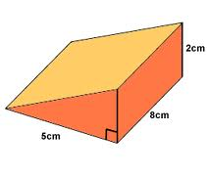

|  |
| --- |
| *PhD Level* |

1. A rectangular prism has a height of 6 inches, a width half the length of the height, and a length four times as long as the width. What is the volume of the prism?
2. For the figure below, if the base is a square with an area of 25 square feet and it has a height of 4 feet, can you determine the volume of the solid? Explain why or why not.

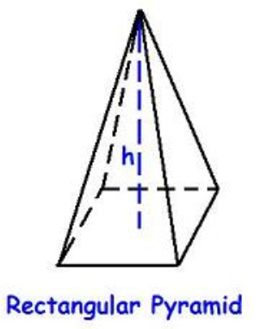

_____________________________________________________________________________________________________________________________________________________________________________________________________________________________________________________________________________________________________________________________________

**Name: ______________________________ Date: _______________________**

**EXIT TICKET**

|  |  |  |  |
| --- | --- | --- | --- |
| Self-assessment | I mastered the learning objective today. | I am almost there. | Need more practice and feedback. |
| Teacher feedback | You mastered the learning objective today. | You are almost there. | You need more practice and feedback. |

1. Look at the triangular prism below. Each triangular face of the prism has a base of 8 cm and a height of 10 cm. The length of the prism is 60 cm. What is the volume of the triangular prism?

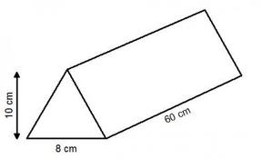

1. What do you need to know in order to find the volume of any right prism?
   1. The length, width, and height
   2. The dimension of each part of each face of the prism
   3. The area of the base and the distance between the bases
   4. It is not possible to find the volume of any right prism without knowing the shapes that it is made of