Global Peace Building and Conflict Resolution: What is conflict?

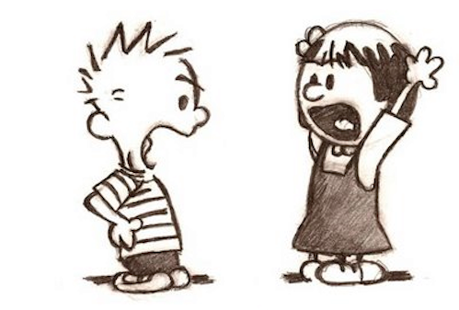
Do Now
What does the word “conflict” mean to you? What examples of conflict can you think
of? Respond in 4-5 sentences minimum. Try your personal best to come up with as
many ideas as possible.

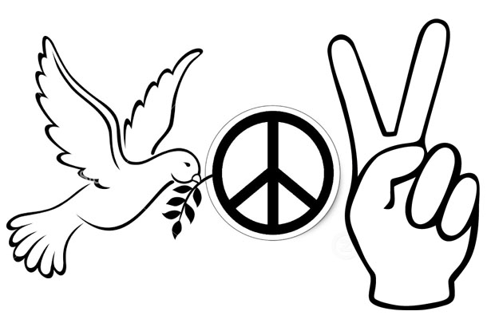
Video Notes
Take notes on the video in the space below. Respond to the following question:
What role do youth play in peace building both locally and globally?

When I say conflict, you think of….
Fill in the blanks with 3 words you think of when you hear the word conflict. Explain your choices.

- When I say conflict, you think of ________________________________.

- When I say conflict, you think of ________________________________.

- When I say conflict, you think of ________________________________.

Why I chose these words:

Discussion Questions
Respond to the following discussion questions in 3-4 complete and detailed sentences each (minimum).

1. Why do you think the words you chose are frequently associated with conflict?

2. Is a fight different than an argument? Why or why not? Explain your response.

3. Why do you think that conflicts often become violent?

4. Do you think conflict is always bad or negative? Can conflict be positive or have a good ending? Explain your response.

5. Can you think of a conflict you experienced that ended up being positive and that helped you learn something about yourself or someone else? If you cannot think of an example, do you think it is possible for a conflict to have this outcome? Why or why not? Explain your response.

Honors Extension Activity
On a separate sheet of paper, make a list of examples of each of the following types of conflict. Brainstorm as many examples of each type of conflict as possible. Use complete and detailed sentences.

1. Personal—something that directly involved or impacted you
2. Local—something that happened in your community, school, or state
3. National—something that happened in the country
4. International— something that happened in the world
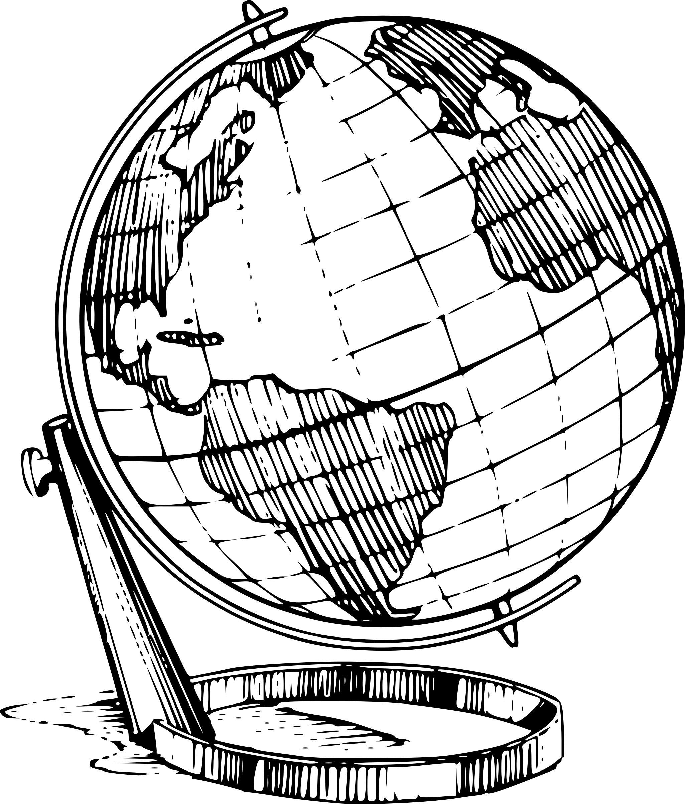

Exit Ticket – How can conflict be defined? What is conflict?

